SQL

To change sql passward :

1. ALTER USER 'root'@'localhost' IDENTIFIED WITH mysql_native_password BY 'password';
2. flush privileges;

SQL : structured query language .

🡺DATABASE:

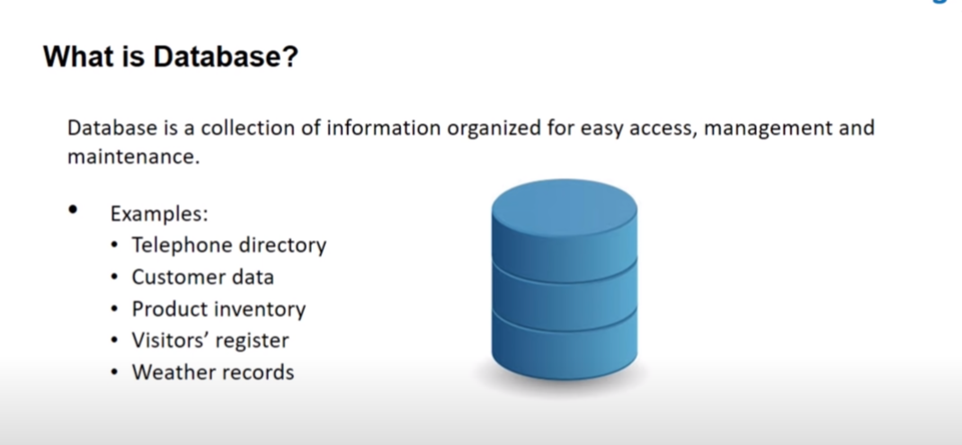

**🡺 Types of data model :**

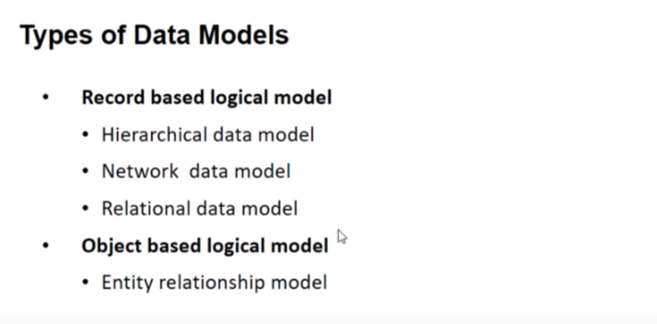

**Normalization :**

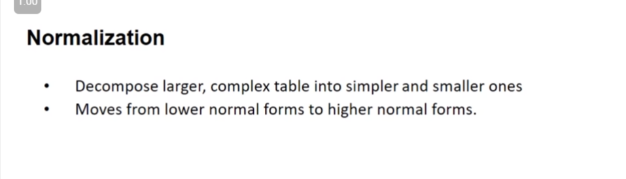

**Type of normalization:**

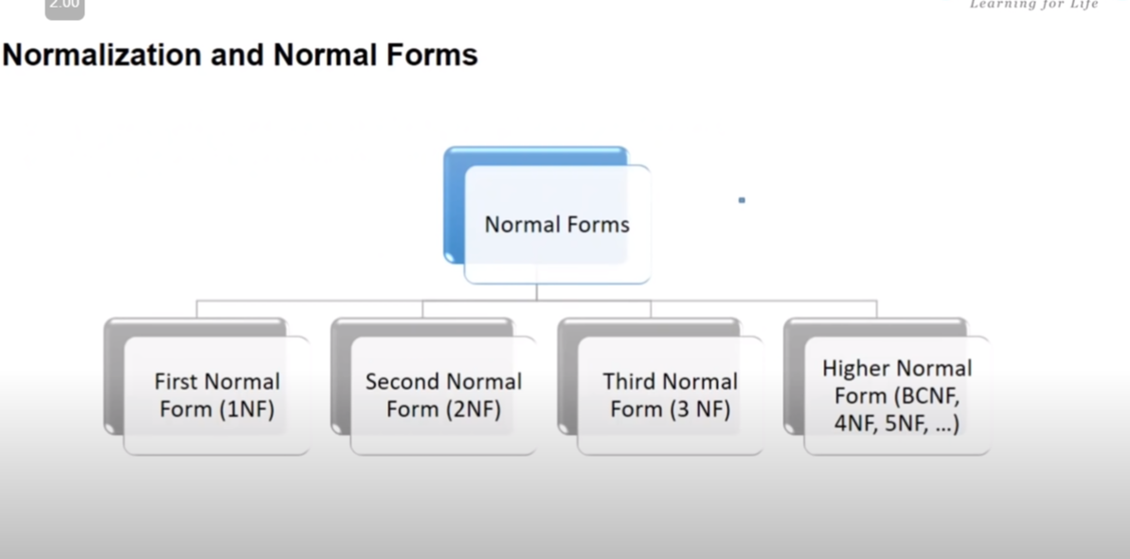

**Need of Normalization:**

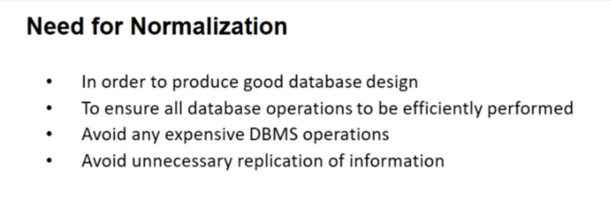

**Example of complex data :**

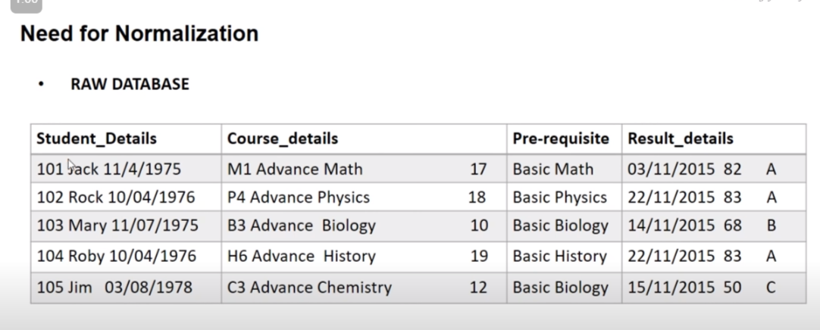

**Functional dependence :**

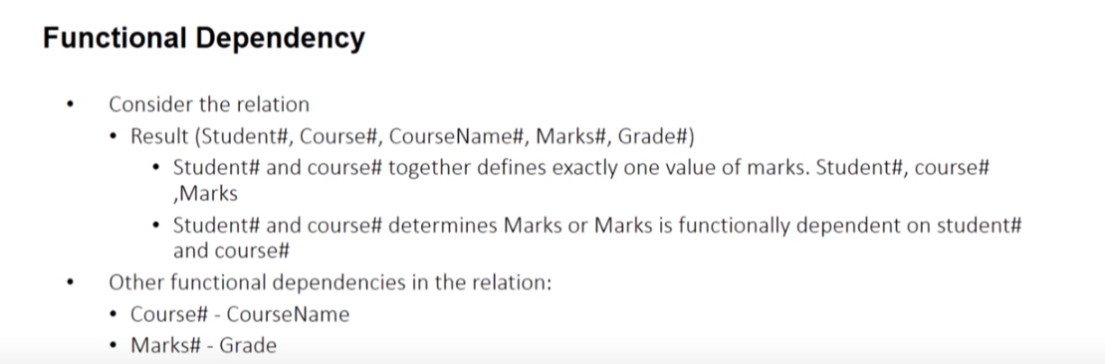

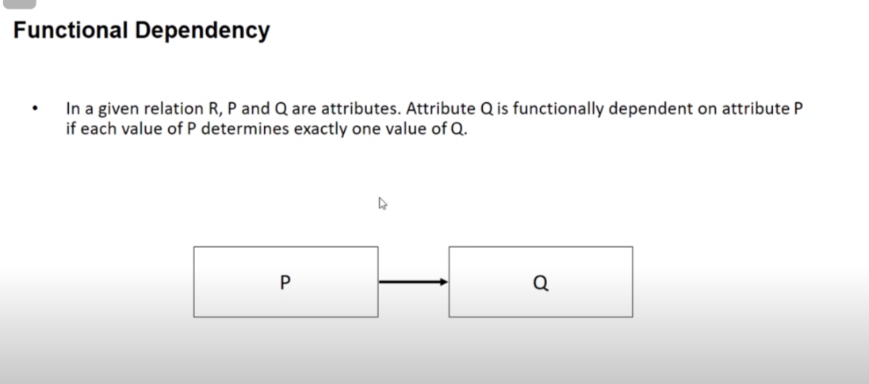

**Types of functional dependence :**

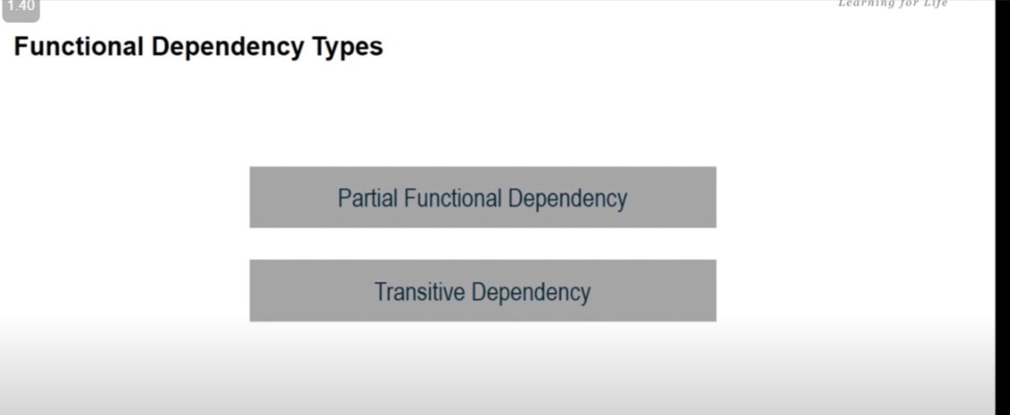

**1.partial dependence :**

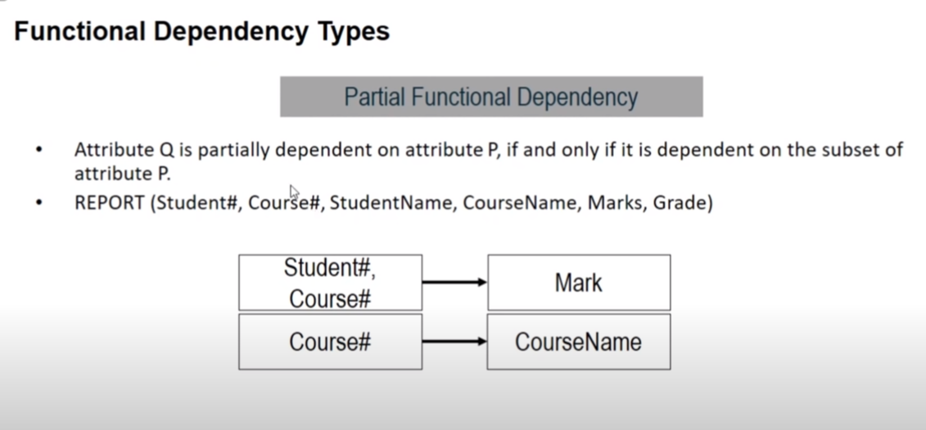

**2.Transitive dependence :**

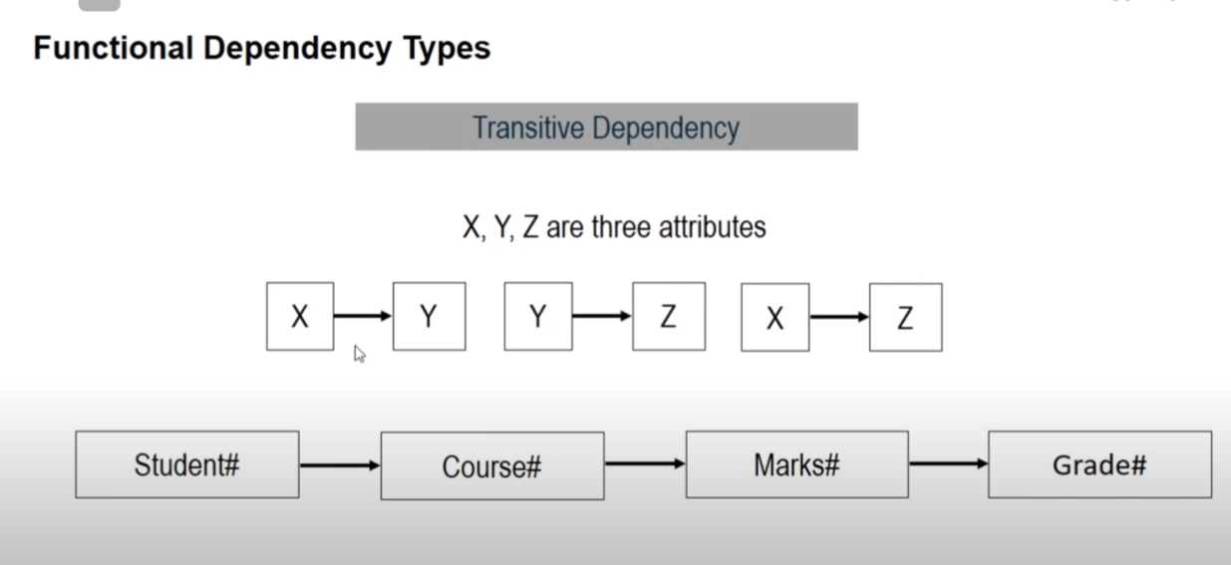

**Type of normalization :**

**1 Normal :**

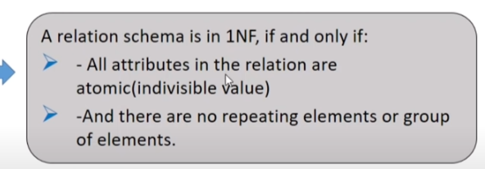

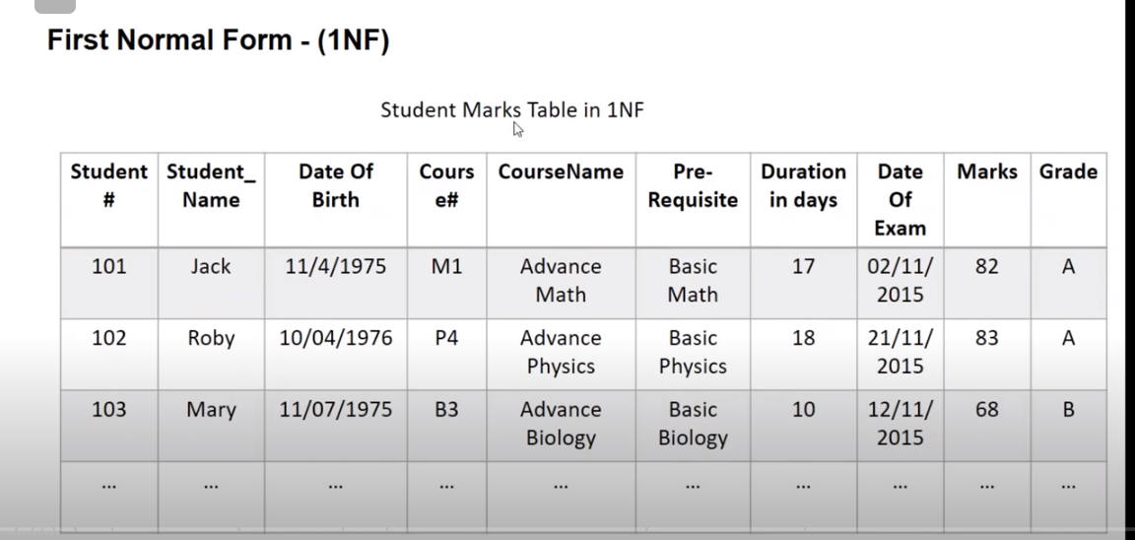

**2. 2N normal :**

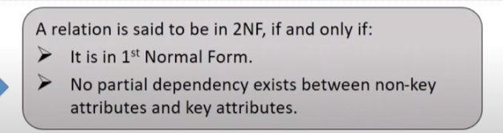



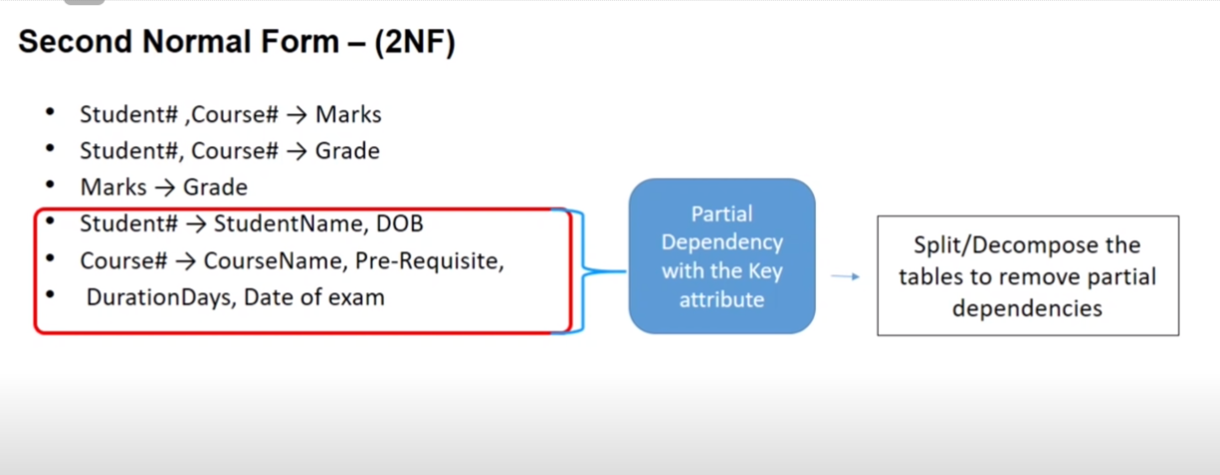

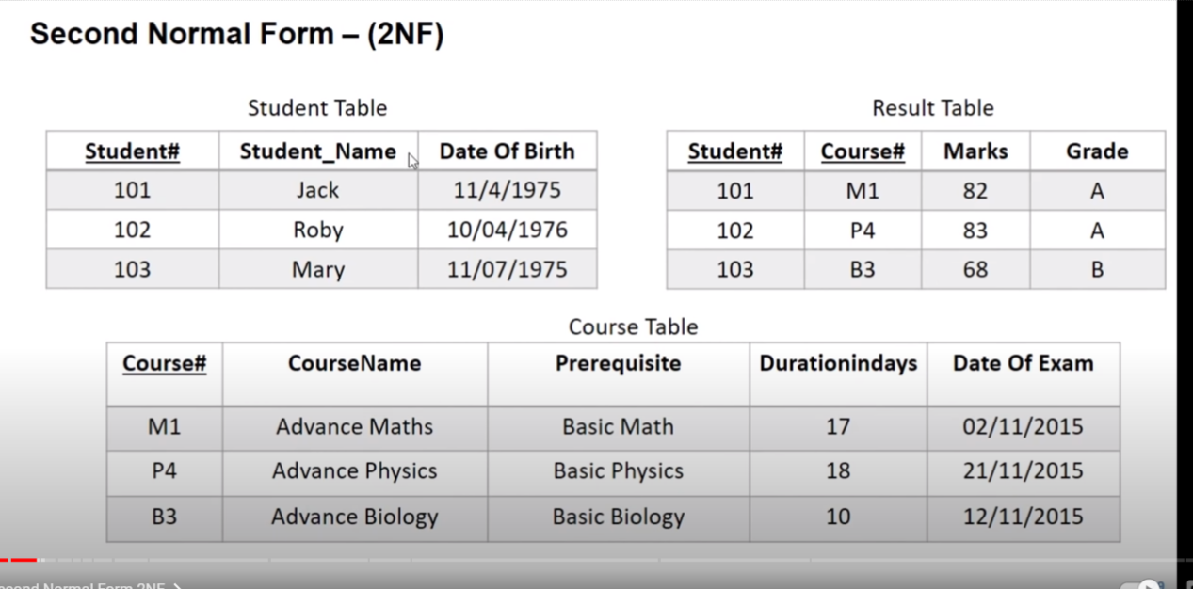

3. 3N normal :

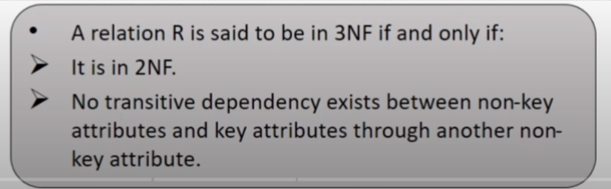

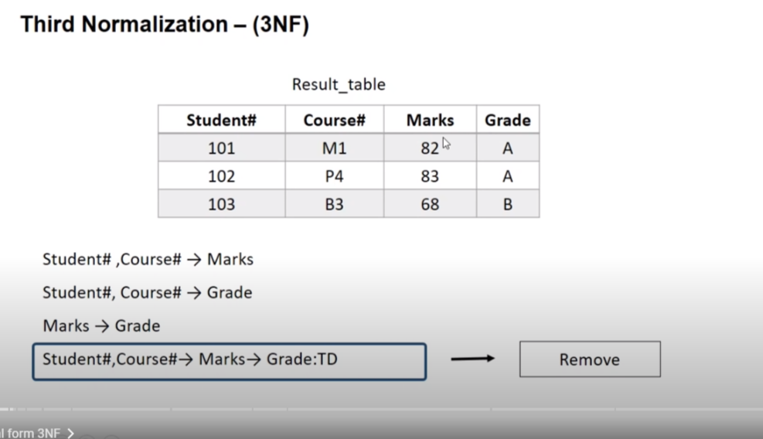

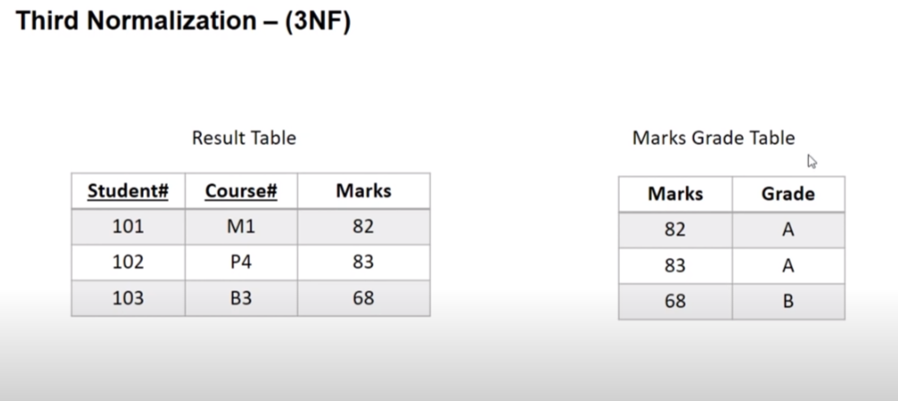

MYSQL installation:

i) Link : <https://www.mysql.com/downloads/>

ii) Check whether it install:

Open-> cmd -> MySQL --version

iii) To start MySQL in cmd :

mysql -u root -p

password : Ajaj13994010#

What SQL?

SQL is a programming language. Through we communicate with the database.

Commnent in mysql :

1. Single line comment : # or –
2. Multi line comment : /* */

🡺 SQL datatypes :

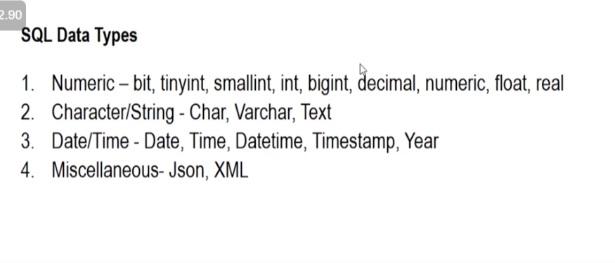

🡺 SQL CONSTAINT :

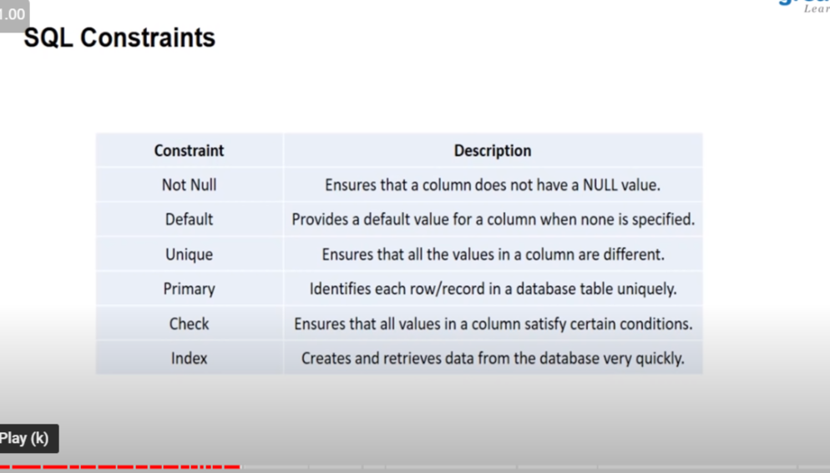

1. Primary key()

create table student(

-> id int not null,

-> first_name varchar(30),

-> last_name varchar(30),

-> marks int,

-> primary key(id)

-> );

2. check 3. default

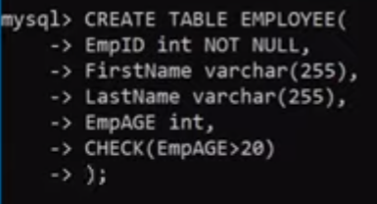 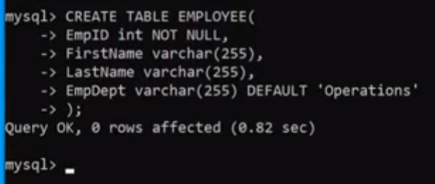

4.index

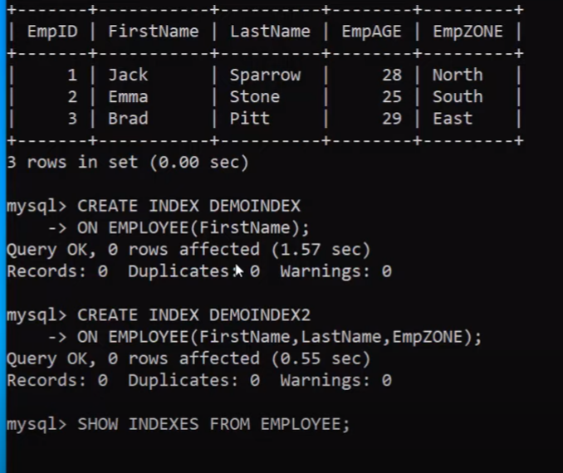

**To delete index : drop index index_name on table_name;**

Sub query language:

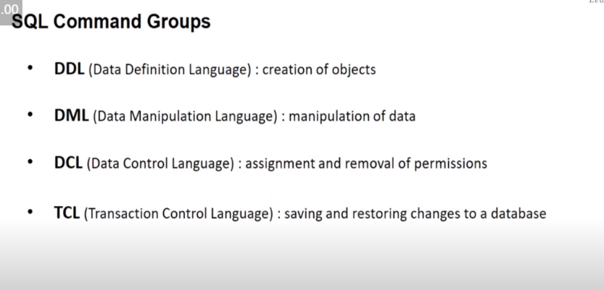

1. Data definition Language :

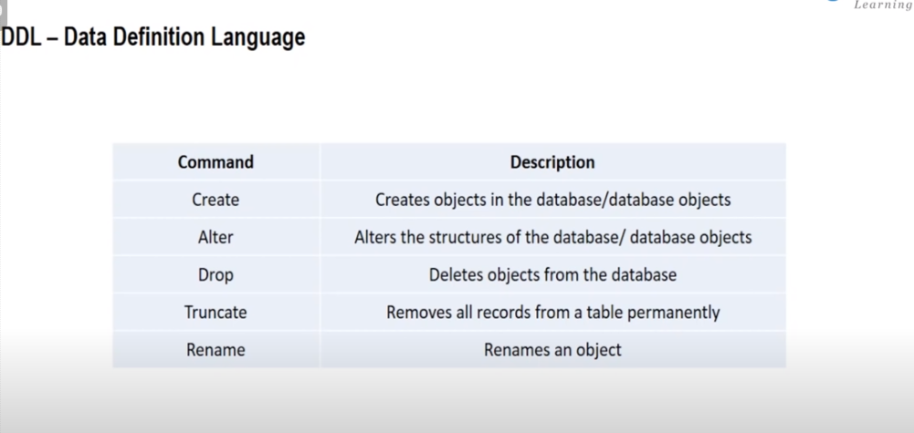

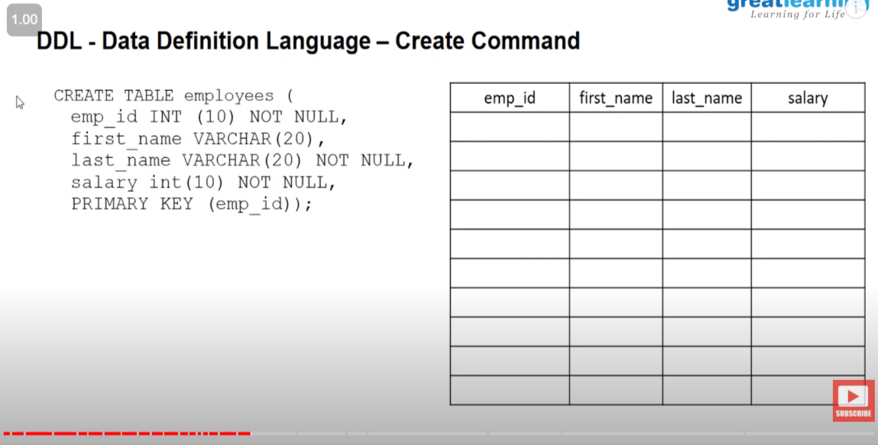

Creating a database in MYSQL :

1. click on the schemas icon from there create your databse .

2. go into the schemas , click on the table ,write your code and click on the first key .

3. in order to see it into tabe : run : select * from table_name .

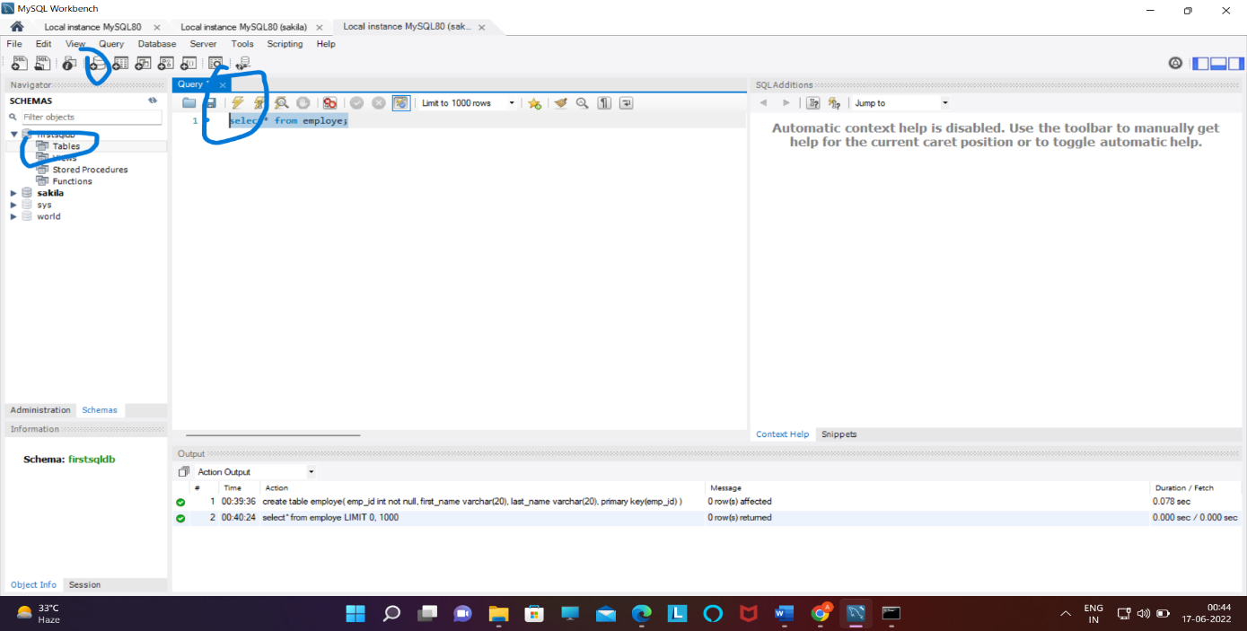

4. to see the field : run : describe table_name .

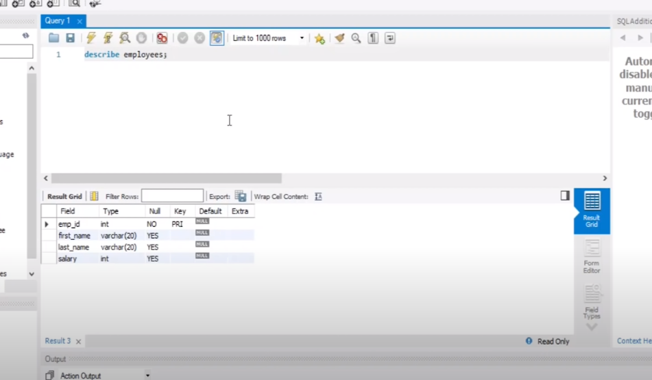

1.B Alter command of DDL;(add colmn);

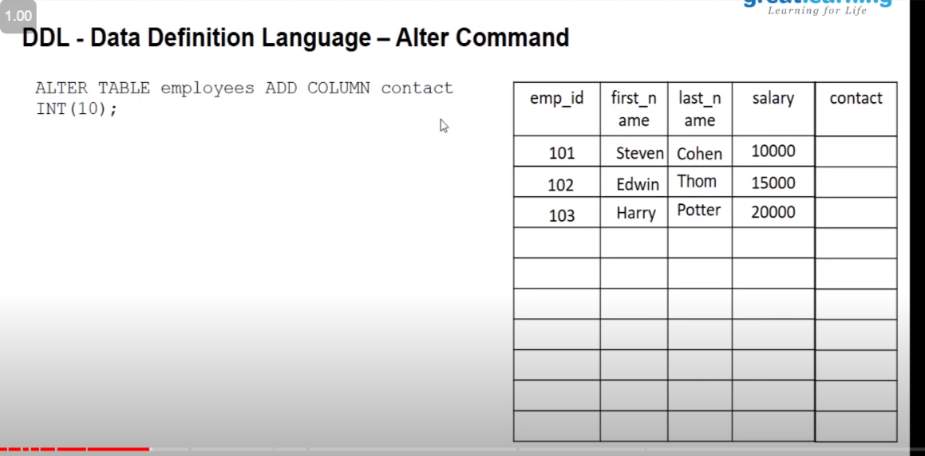

alter table employe add column contact int ;

command for drop column;

alter table table_name drop column column_name;

Rename column;

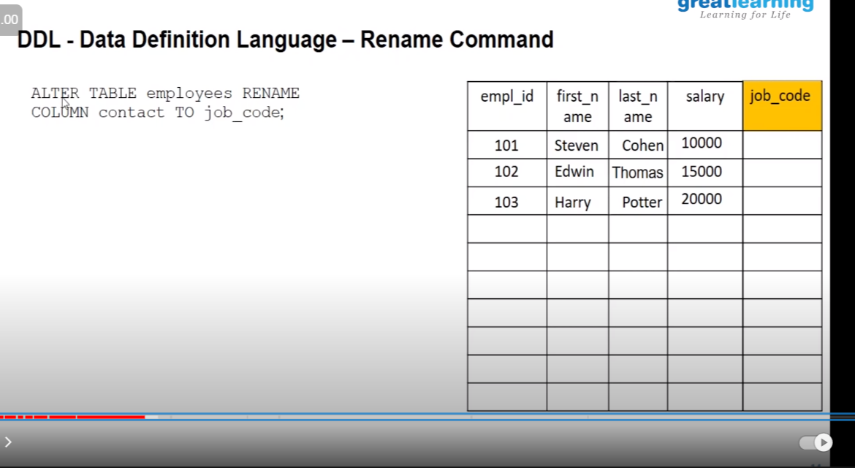

alter table employe rename column emp_id to employe_id;

1.C Truncate :

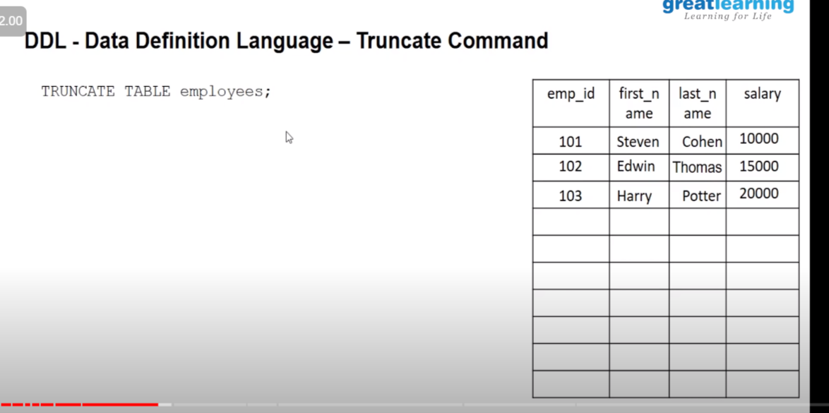

truncate table employe ;

1 .E : drop method :

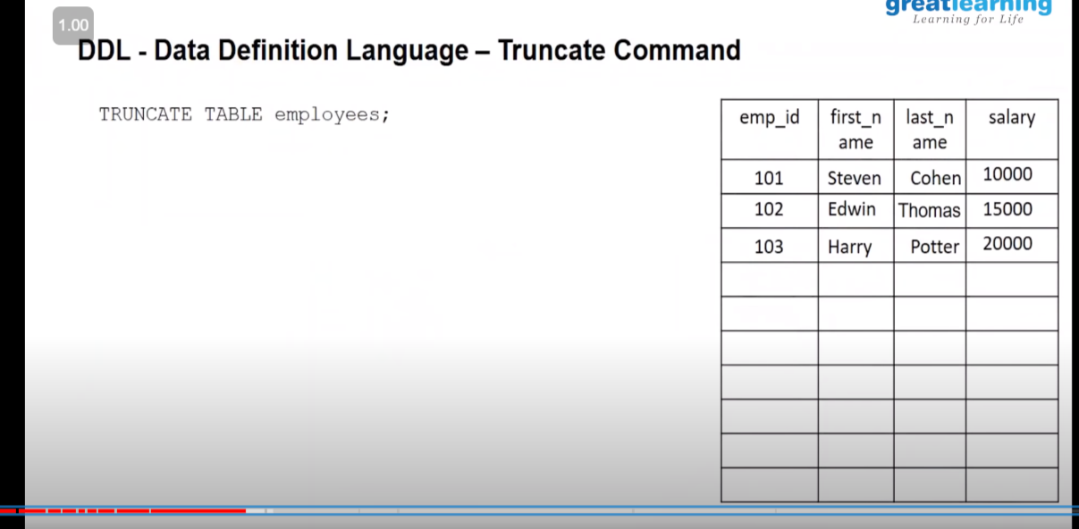

2. DML (Data Manipulation language):

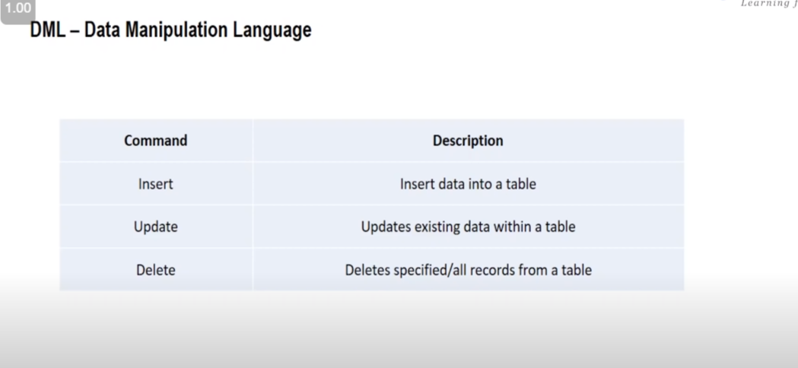

2.A insert operation :

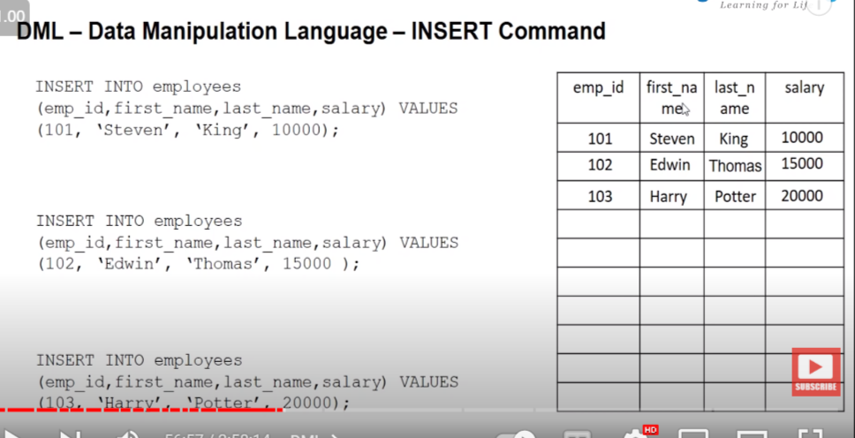

2.B . Update command

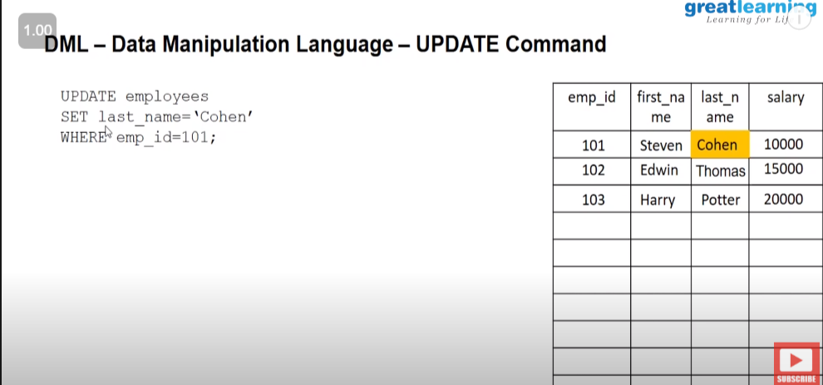

2.C Delete command

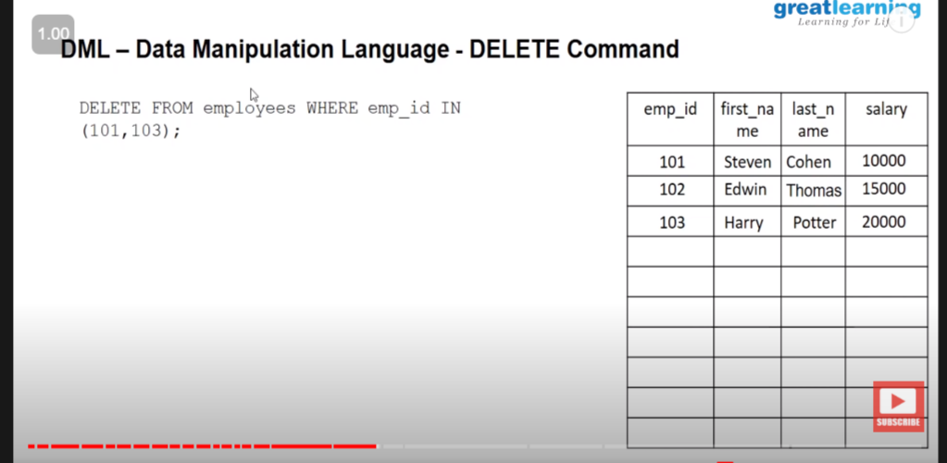

3.DCL (Data Control language )

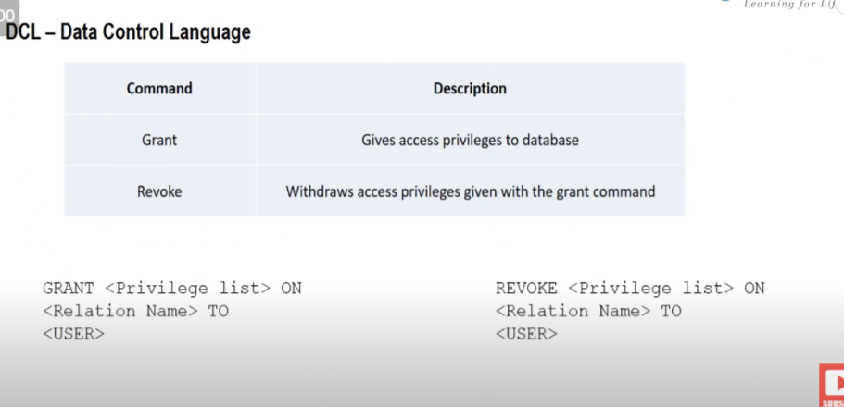

4. TCL (Transition control language)

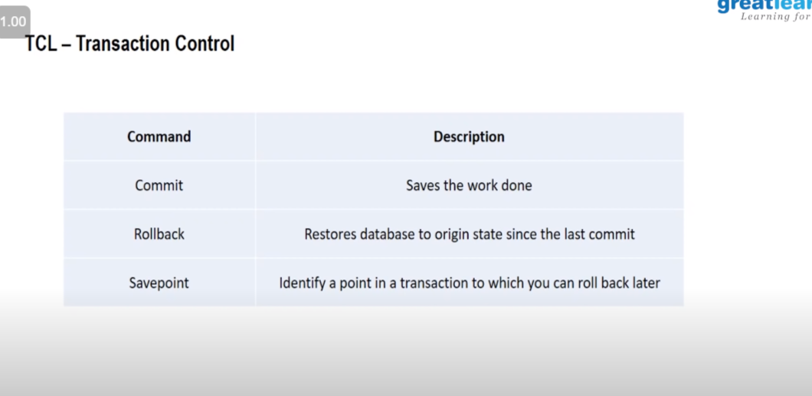

Concept : during showing table by select method if I want to show particular column insited of whole column we can do that by using :

Select column_name1,column_name2 which i want to show instead of using :select * table_name

SQL Operator:

1.

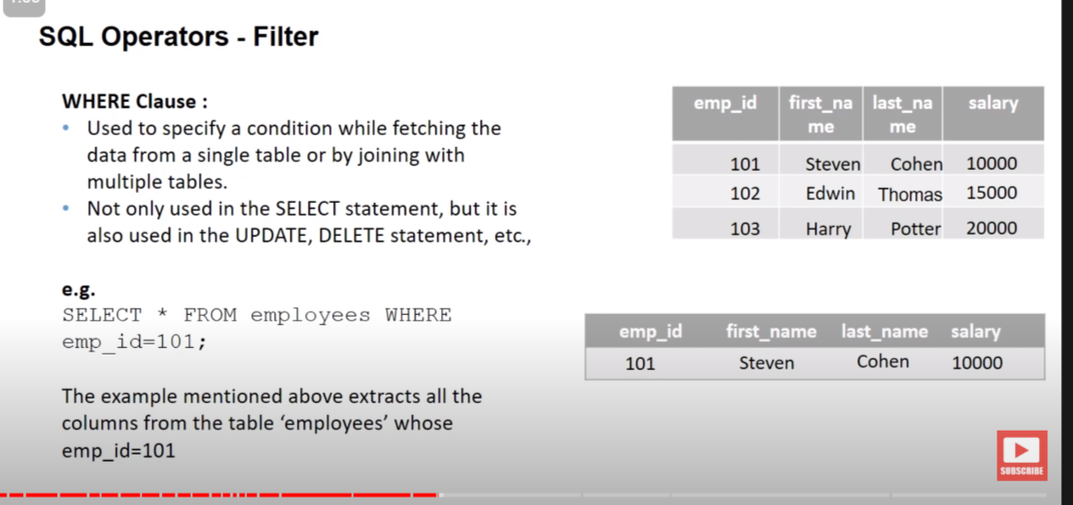

2.

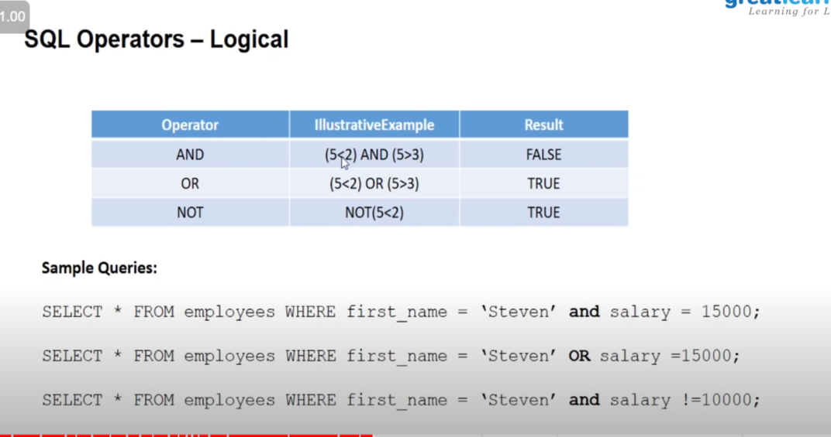

3.

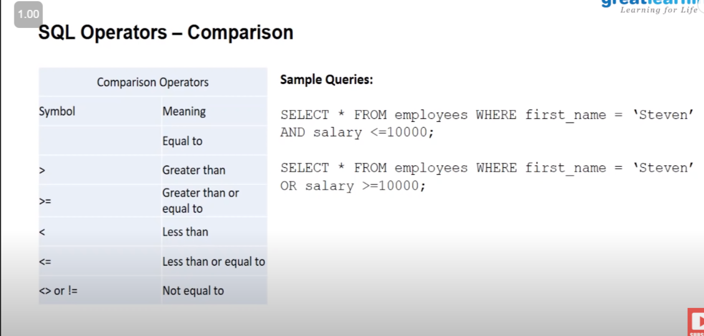

4.

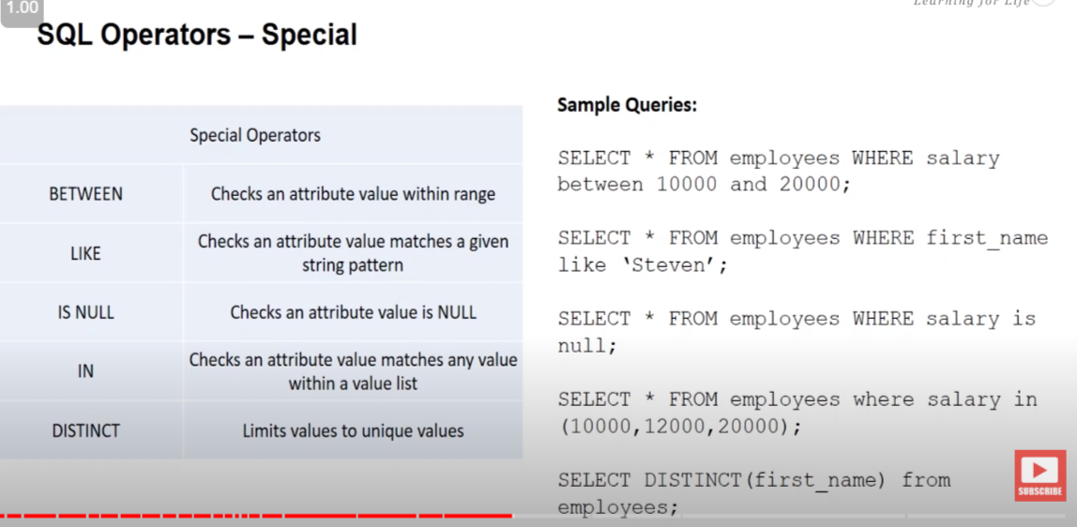

1. select * from employee salary between 12000 and 30000;

Here both 12000 and 30000 is inexculisve .

2. select * from employee last_name like ‘l%’ ; -> it will going to give all the last name starts from l .

5.

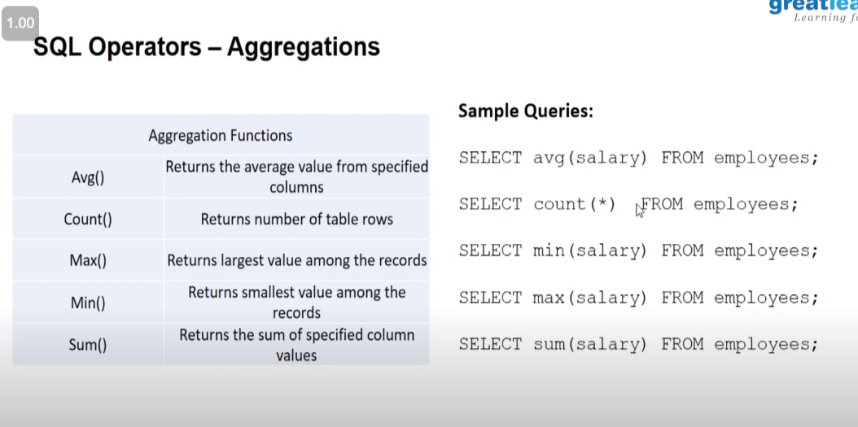

🡺 SQL CLAUSE :

1. Group by :

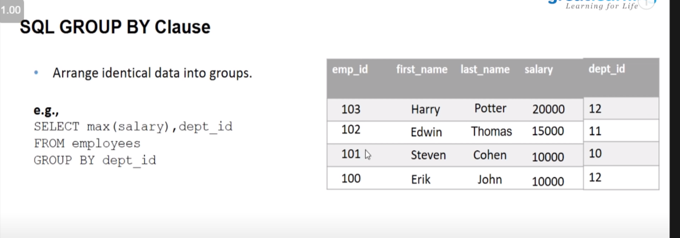

Ex :

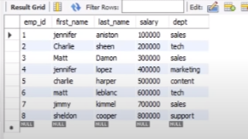

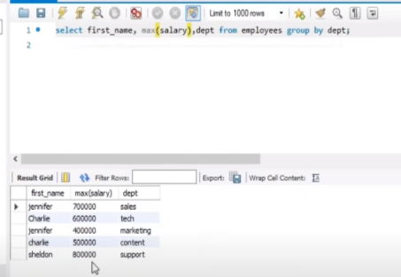

1.b Having clause

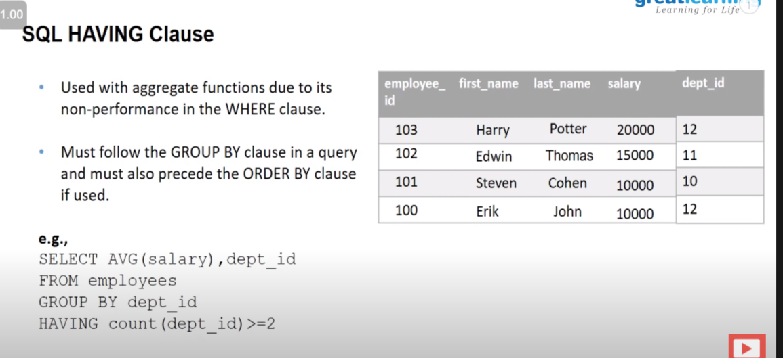

2. Order by :

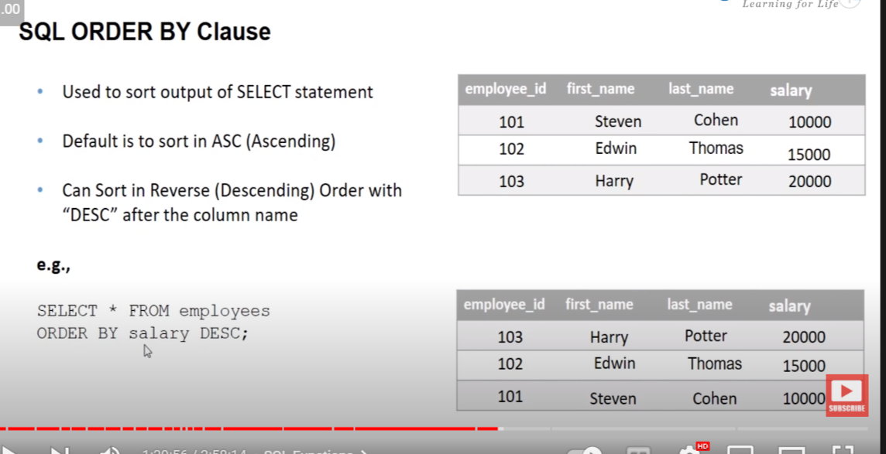

🡺 SQL Function:

1. union

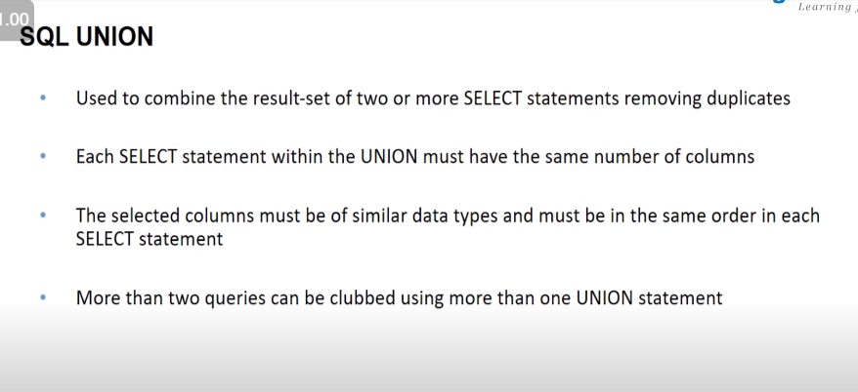

Eg:

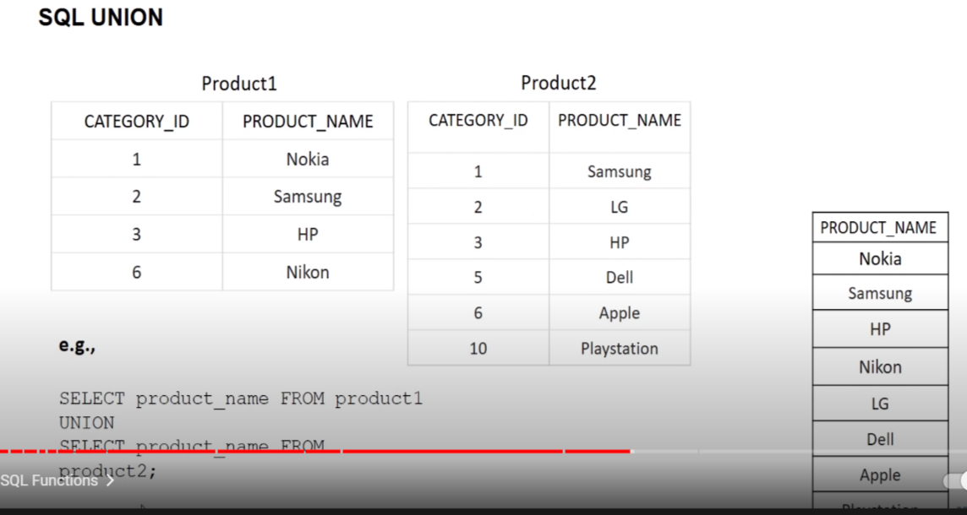

2. Union all

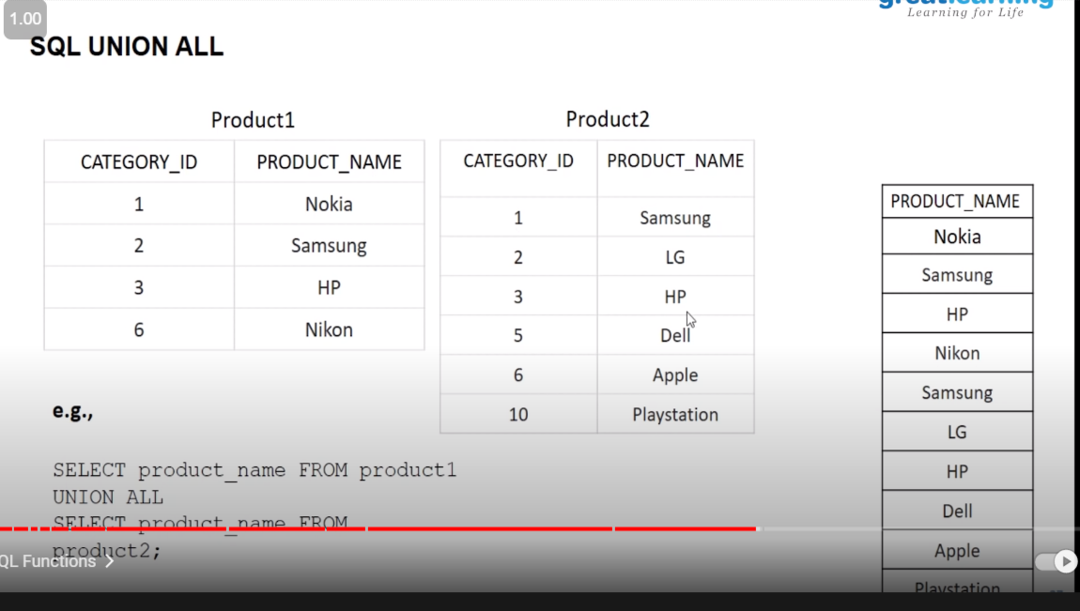

🡺 SQL JOIN :

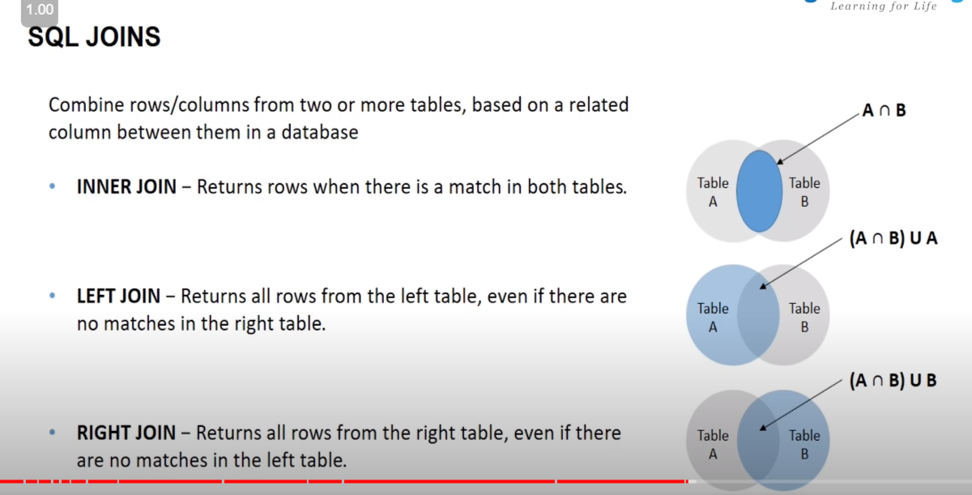

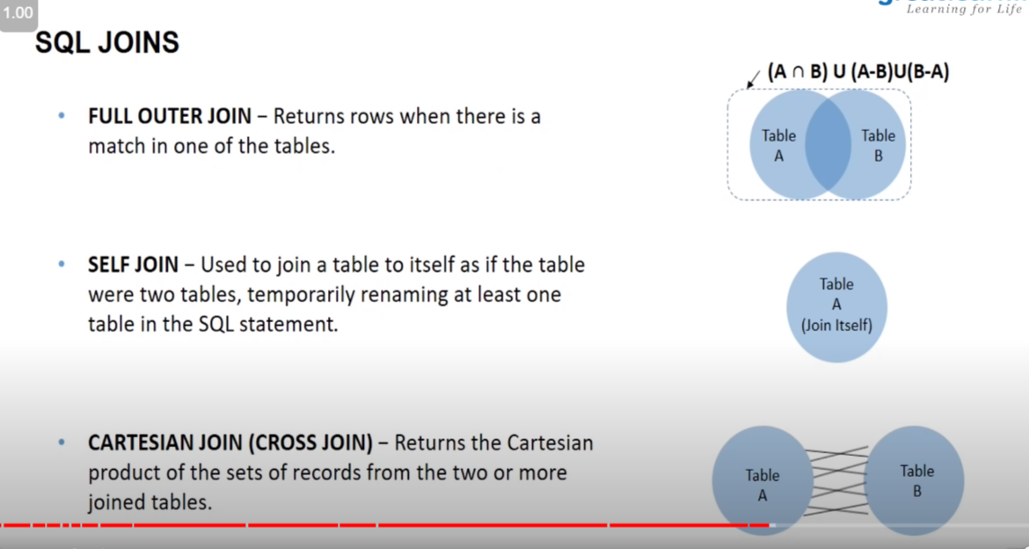

1. INNER JOIN :

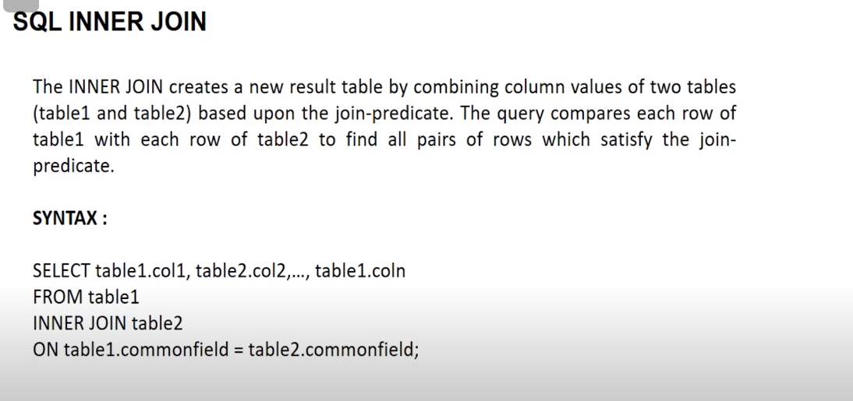

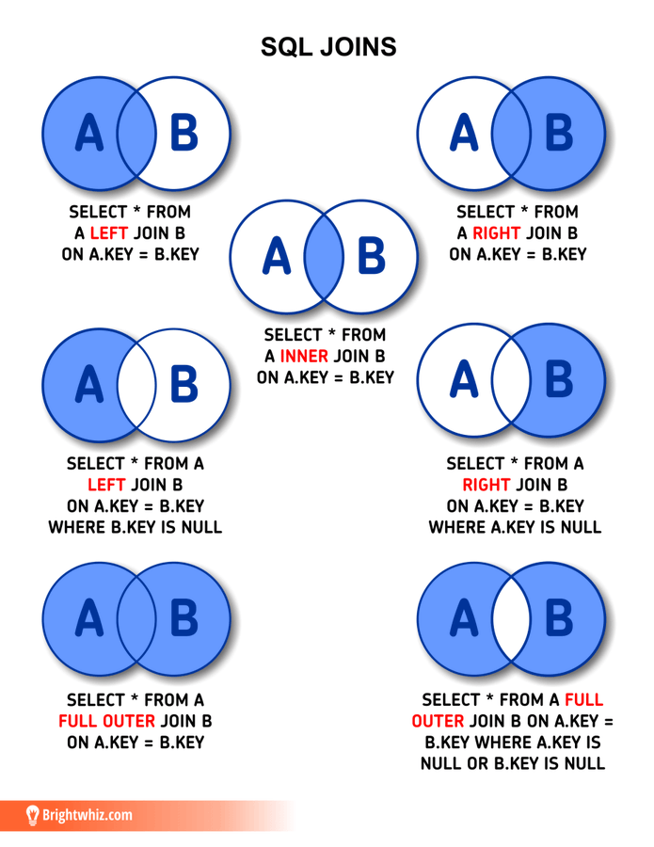

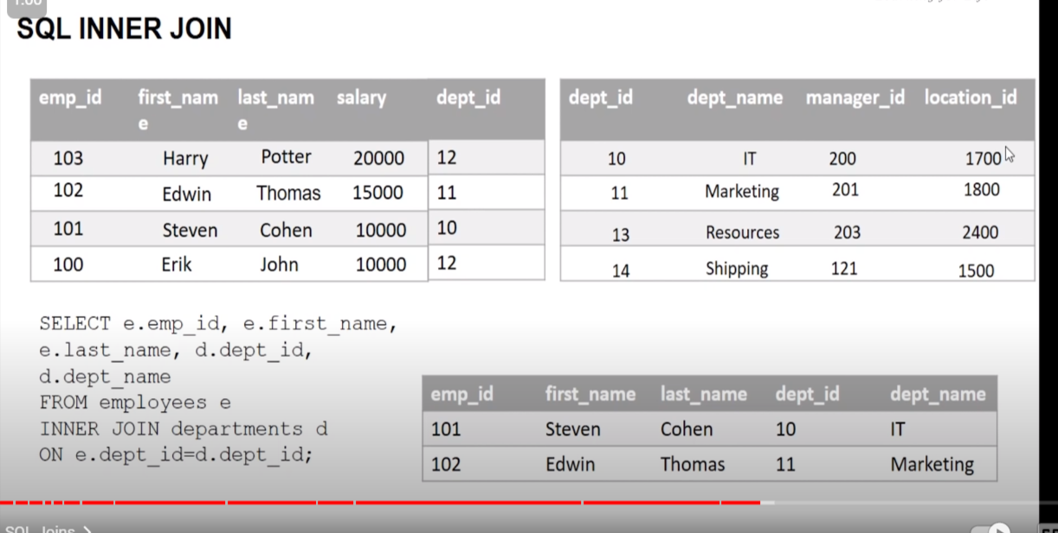

B. LEFT JOIN :

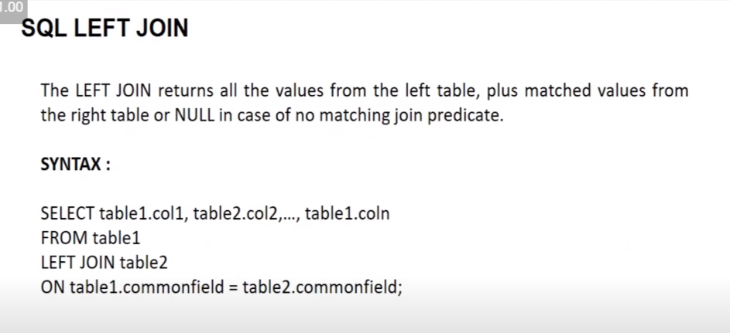

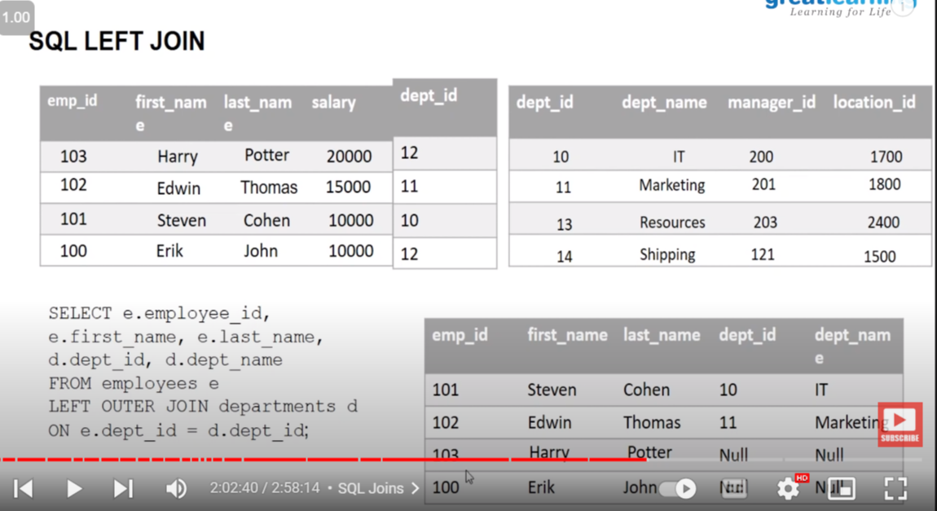

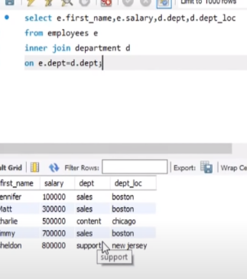

C. Right Join

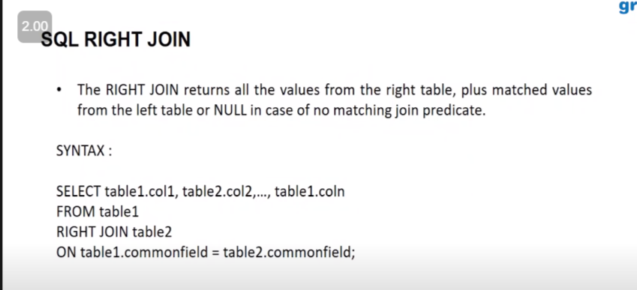

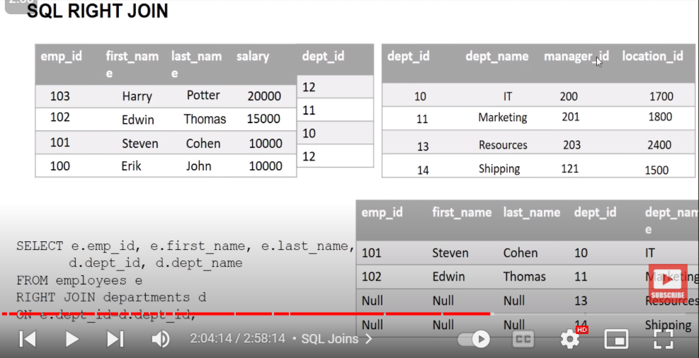

C .Outer Join

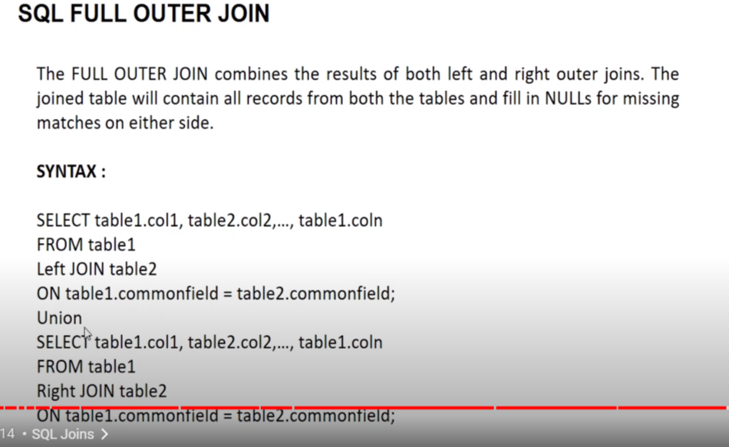

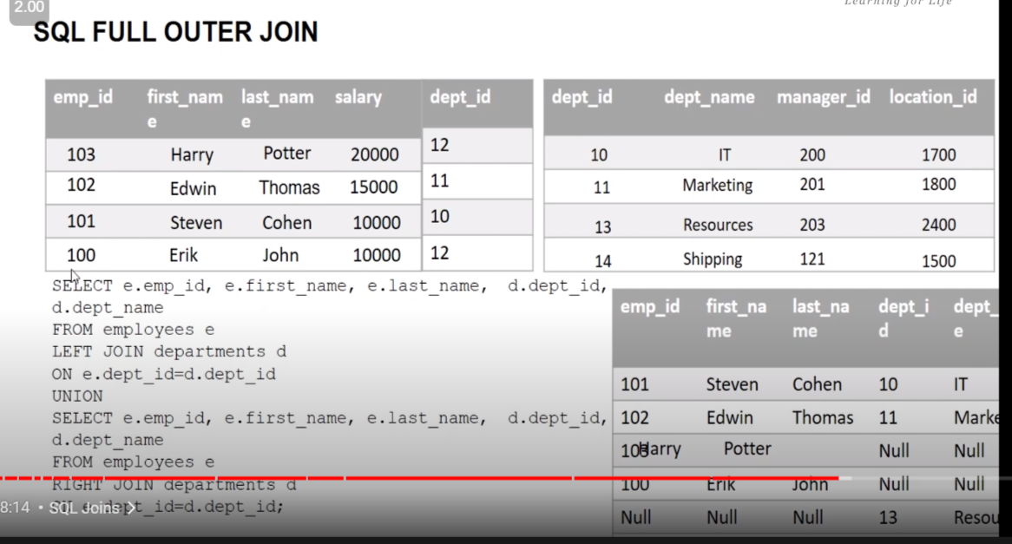

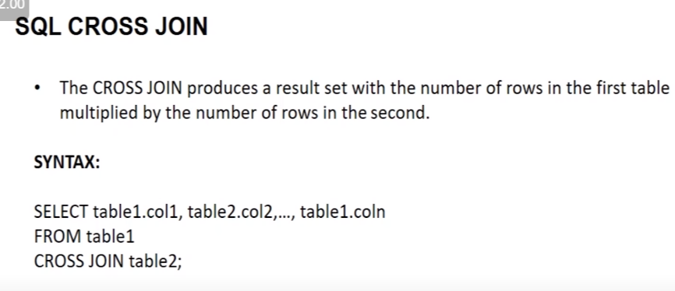

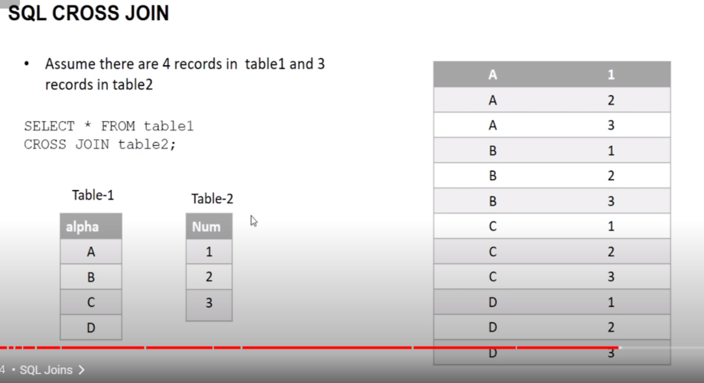

1. To see all the database :

Show databases;

1.2 to create databases : create database database_name;

1. To select a data base :

Use name_of_dataBase;

* 1. To drop a database :

drop database database_name;

1. To see all the table in particular database :

First select your database by use->show table;

1. To see the entry of of a paticluar table :

Select * from table_name:

1. To trim any thing from the string :

Substr(name_of_string(eg:name),index) // index starting from 1;

1. To know the length of any string :

Char_length(string_name)

7. Command for creating a new database :

i)Create database database_name;

ii)Use database_name;

8. To modify the data types of any column :

alter table table_name modify column_name data_types;

9.data types for :

i) date :date

ii)min and sec : datatime

iii) min and sec and timeinterval : timestamp

note :while inserting their value we use : current_data() for all

if we want to make changes in the above :

we use :

update table_name set filed_name=date_add(filed_name,interval 1 day);

note :for decreasing we give (interval -1 day)

10. if I want to display only n first detail :

Select * from table_name limit n;

Questions :

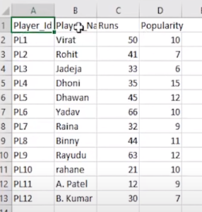 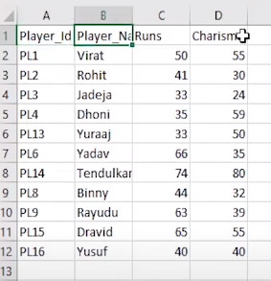

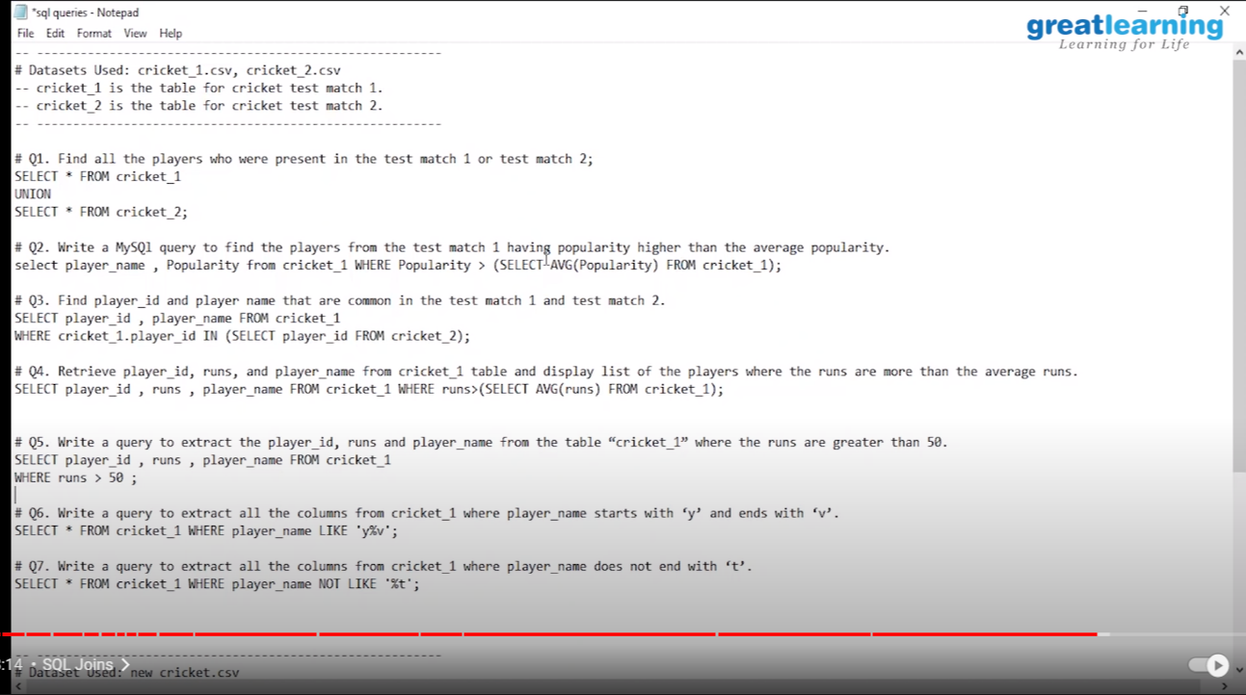

Concept : in sql indexing start from 1 not from 0;

Alias :

Select first_name as name1,last_name as name2 from employe;

Use of : in or not in

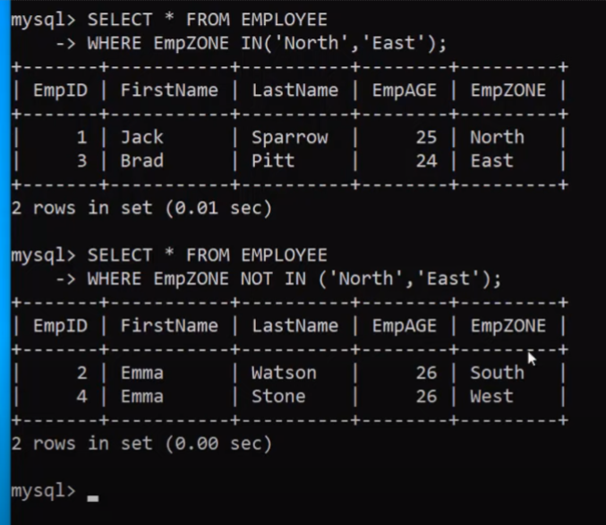

CASE :

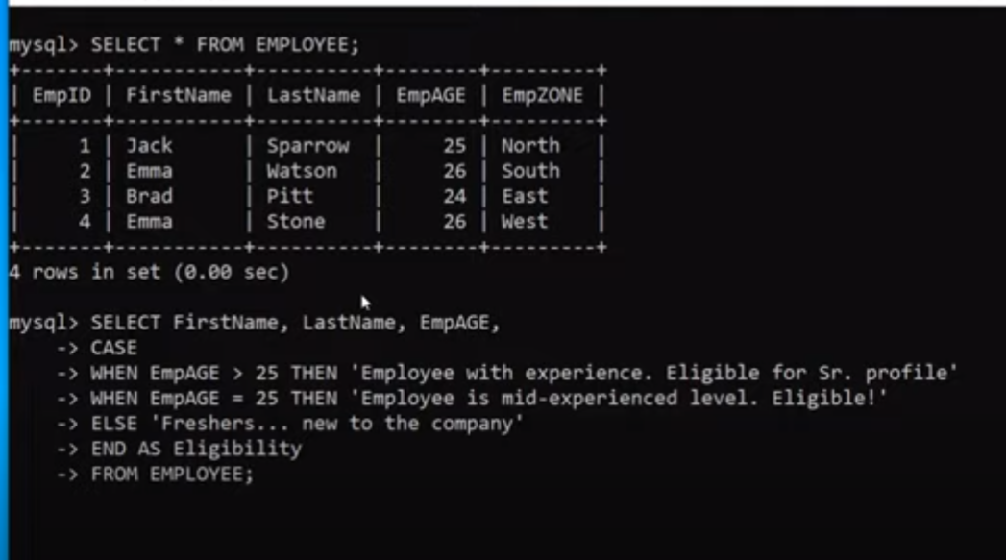

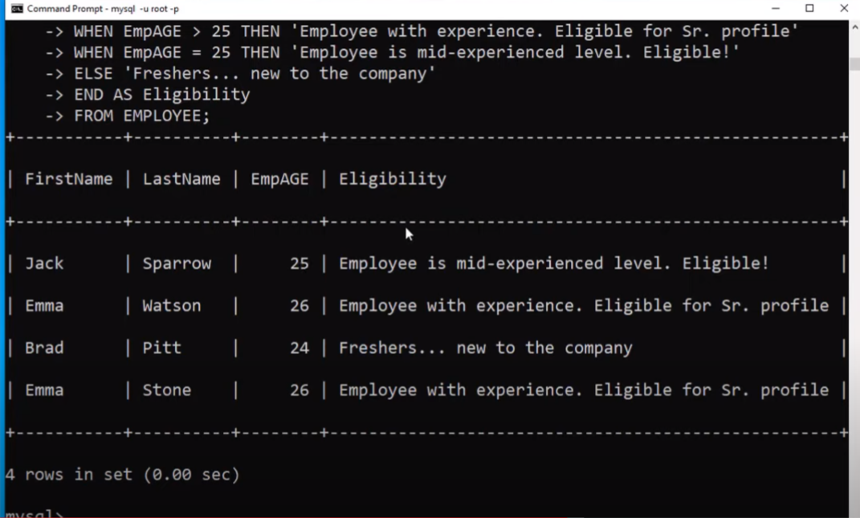

Auto_increment : it will automatically increase from 1 genrally used for id :

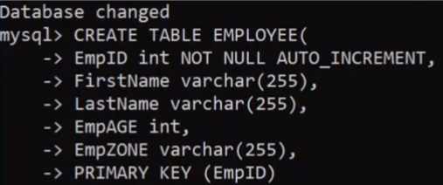

Insert multiple record in table :

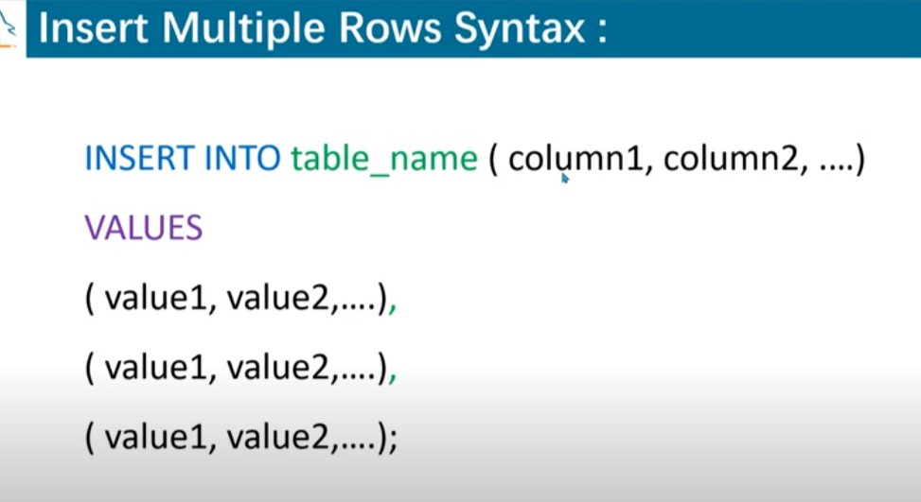

Regular expression :

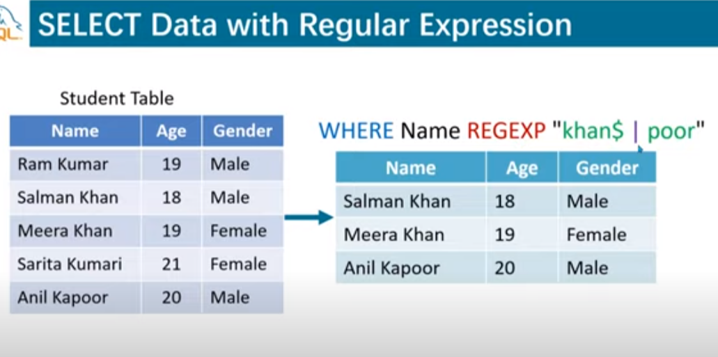

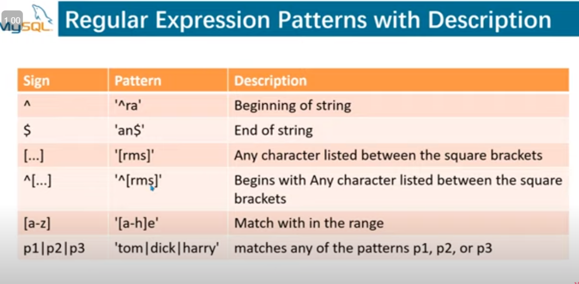

Offset : it always used with limit .

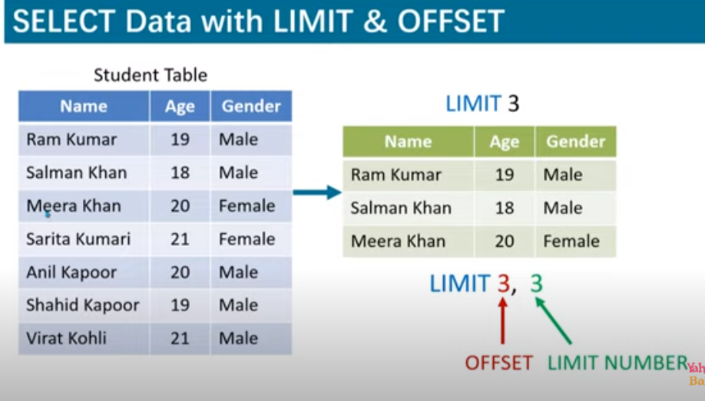

Above means : it will give 3 result after 3 entry

Difference between 1 and 2 :

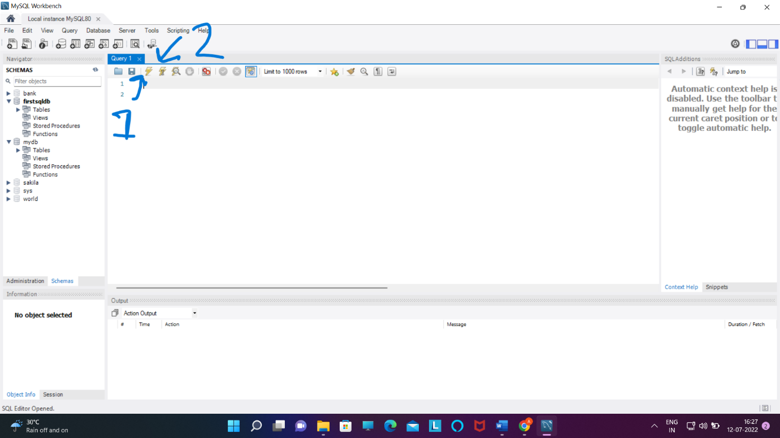

On clicking on 1 :it will execute all the line written in give space.

On clicking on 2 : it will going to run only particular line , jise par cursor ho .

Eg :

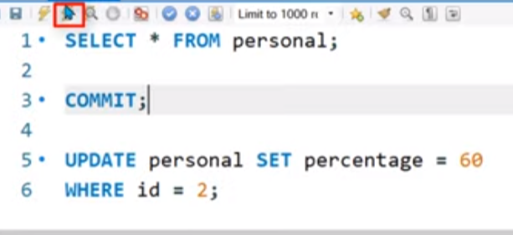

Note it will going to excute only : commit;

Roolback and commit :

Difference between rollback and commit :

1. Both of them will work for insert , update and delete only.
2. By commit we permanently commit the changes .
3. By rollback we can rollback the changes to last commit

To make commit and rollback effective : we need to make some changes :

MYSQL workbench-> edit ->preferences->sql execution ->unchecked new connection auto commit mode -> restart workbench again .

To commit just run command :

Commit;

To roolback just run command :

Rollback;

🡺 Adding a primary key by alter method :

Alter table table_name add primary key (id);

🡺 Setting foreign key :

Foreign key is used to connect to table by the id of second to first one .

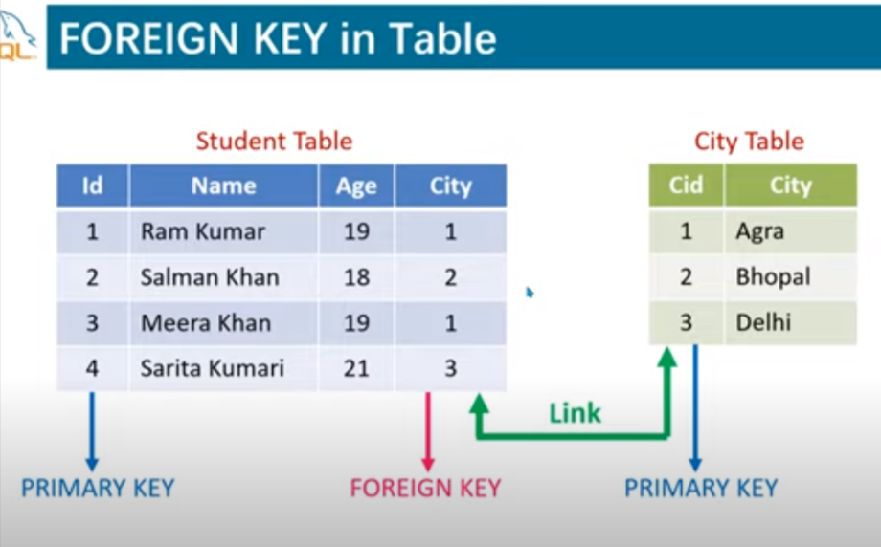

Syntax :

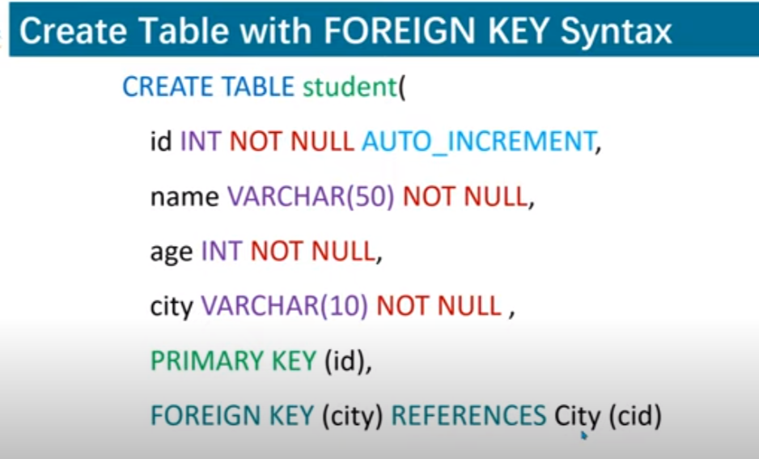

Adding forign key by alter :

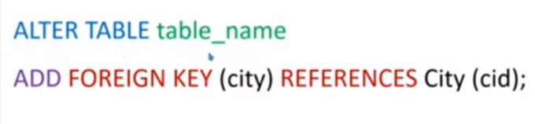

🡺 if clause:

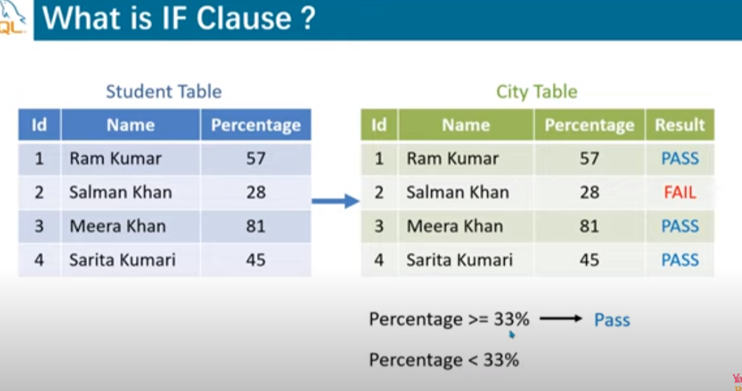

Syntax:

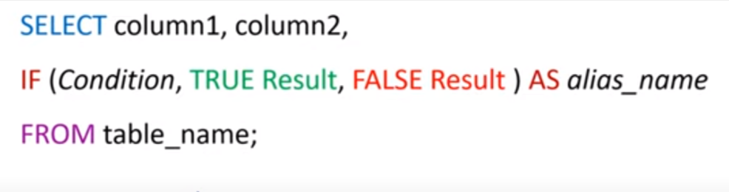

SQL Athematic function:

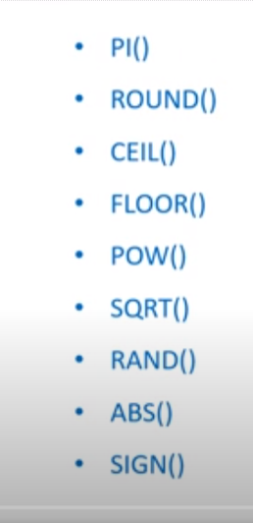

Sign : if negative : give -1

If positive give 1

If zero give 0

Note we can perform addition ,subtraction ,multiplication and division in mY sql .



🡺 During alias if our alias name have two or more than two words then during name we have to put them in double quote .

Eg :

Seletct first_name as “my name” from table.

🡺 MY SQL string function :

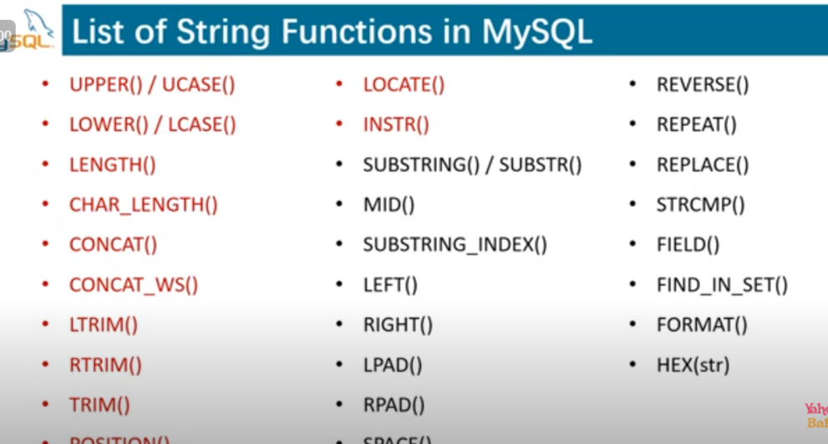

Note : i)string function not going to change the existing string it will going to create as alias so we can give them name as alias.

1. not forget to give alias name because they will not going to change the existing data.

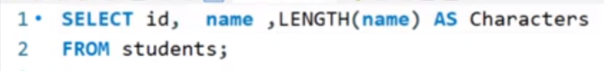

v)concat_ws : first parameter will be separator

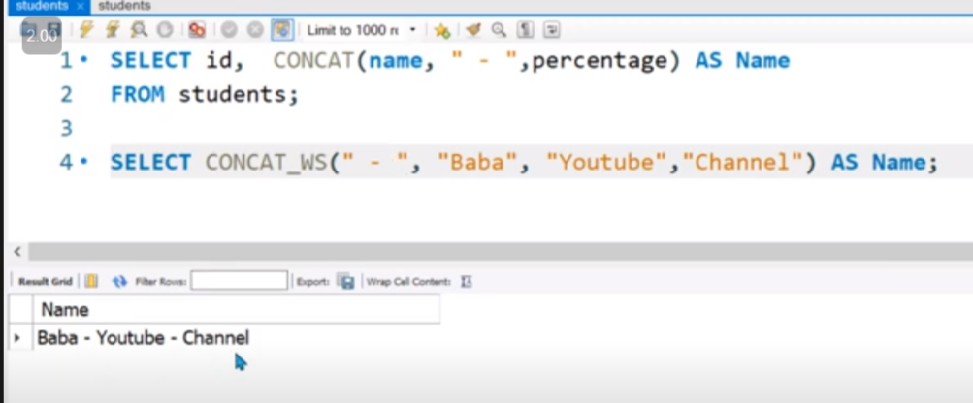

vi)trim is used to remove white space from left and right .

1. length will going to give length in bytes.
2. Left will create a sub string from start to as given in eg : left(string_name,5) //means left se 5 letter
3. Right(string_name,6) : right the 6 character .

v)replace :



View command : it is used to create alias for sub-query or query

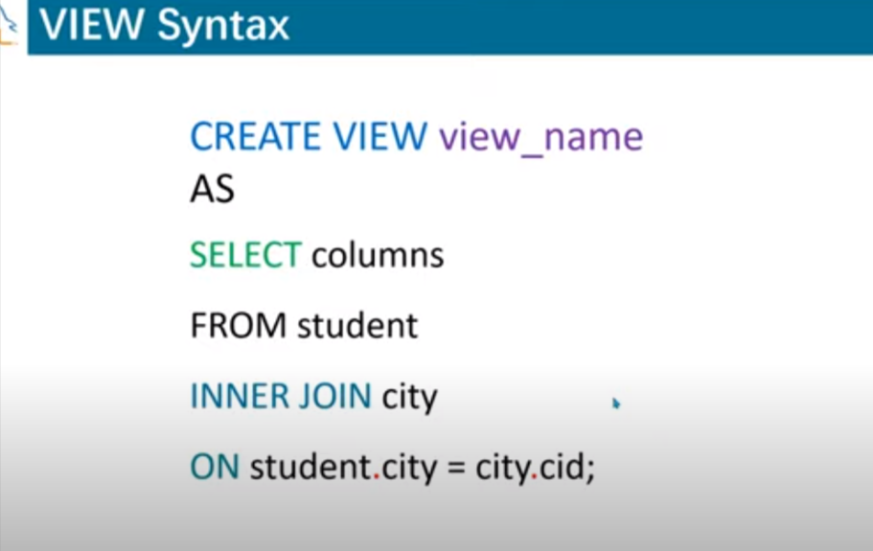

Eg :

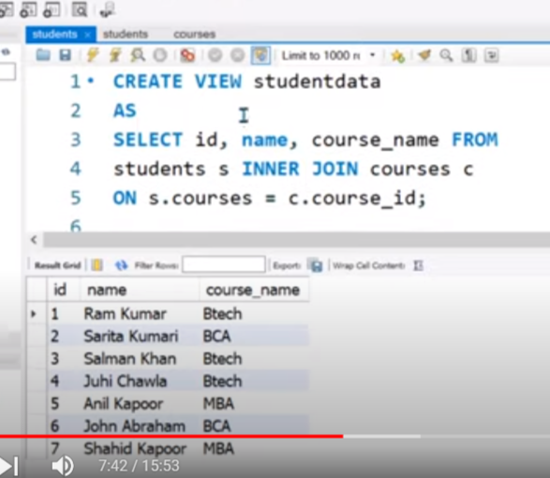

Note :view name should not match with the of table . other wise view will not created .

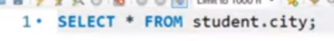

To make changes in : joining three table

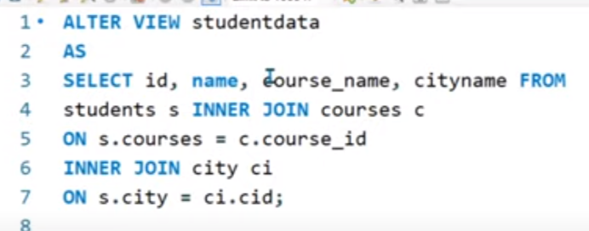

Renaming table :

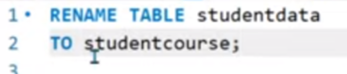

Renaming view :



To delete view :

Drop view view_name;

Advantages and disadvantages of view :

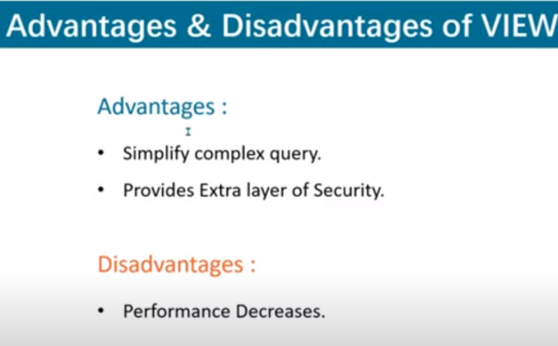

Alter :with the help of alter we can perfom the following property;

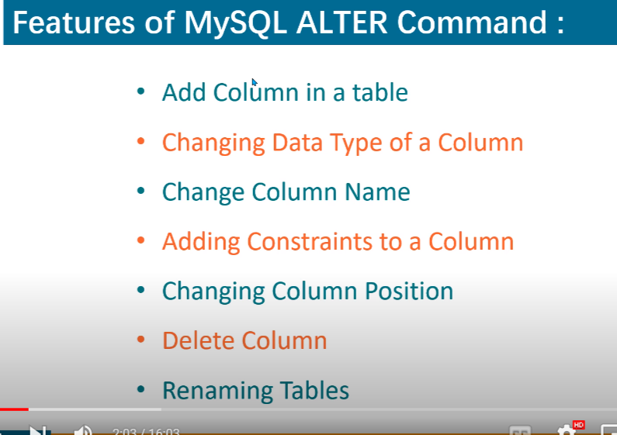

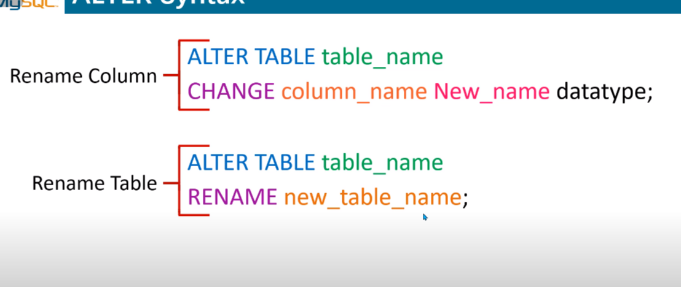

To change the auto increament :

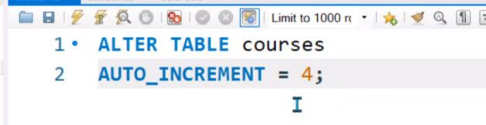

Multiple update :

Note : remember to use comma.

"UPDATE Student SET  Name='{$name}', Adress='{$Adress} ', Class='{$Class}', Phone='{$Phone}' WHERE id={$id}"

Inner join with the primary key :

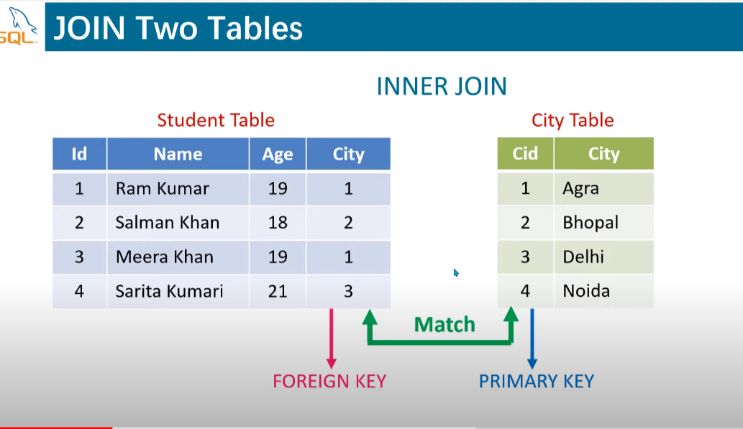

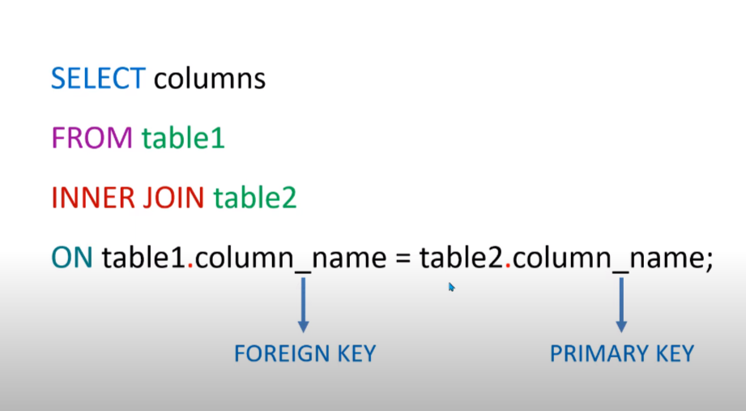

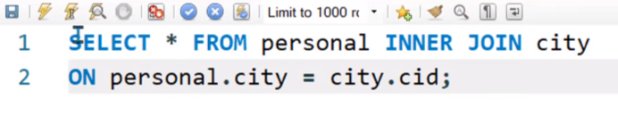

==>SUBQUERY

1.TYPE OF SUBQUERY

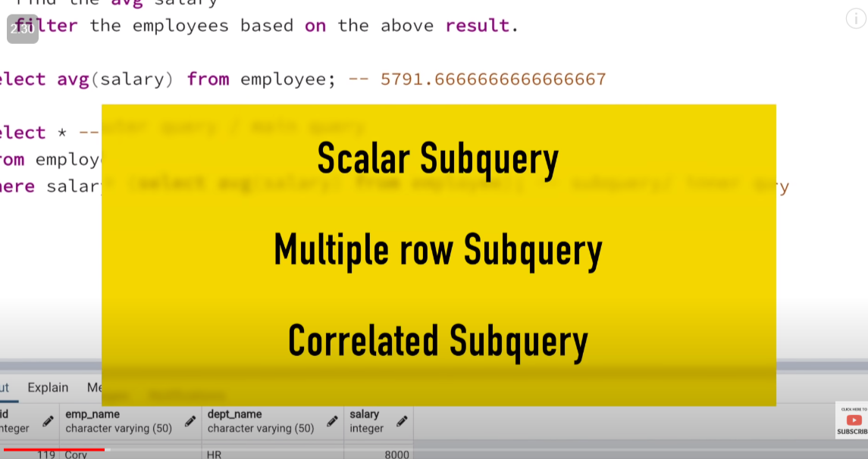

A)scalar subquery : it always return 1 row and 1 column

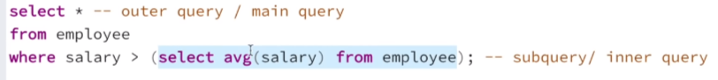

B)Multiple subquery type :

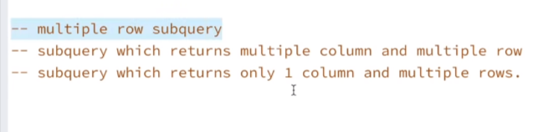

eg :of multiple row and multiple column

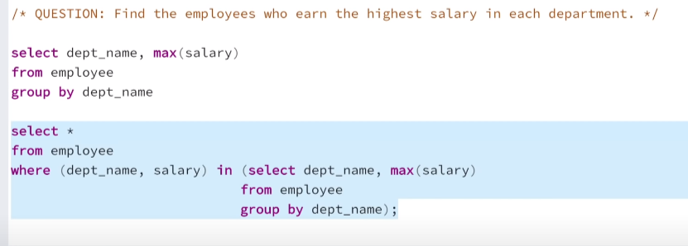

eg: of 1 column and multiple row

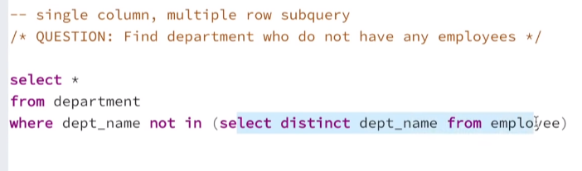

3.Corelated subquery : query in which subqurey is dependent on the outer query

eg :

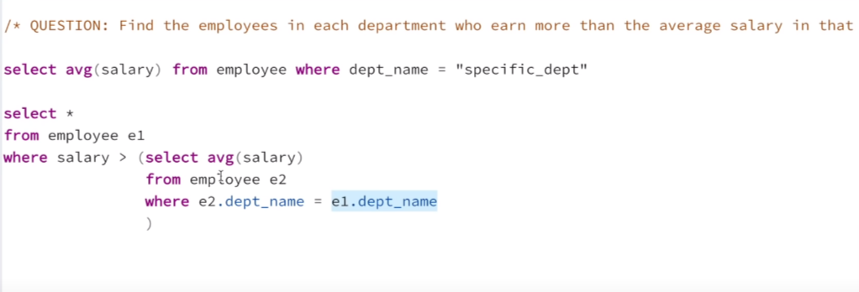

note : corelated is not good to do due to its time complexity

another example :

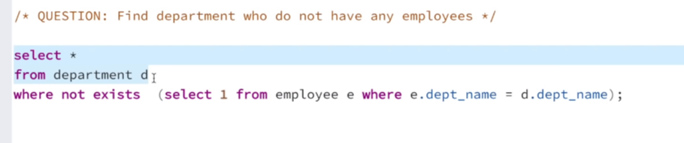

4.nested subquery

question :

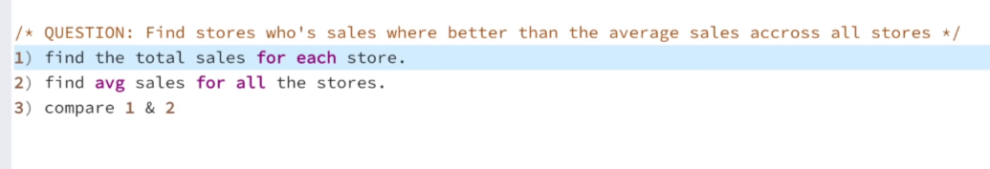

part 1 :

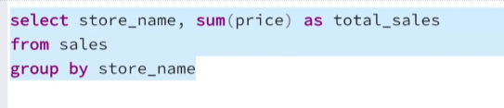

part 2 :

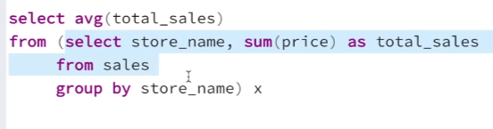

part 3 :

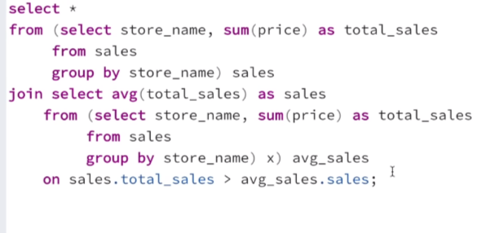

==>if a paticular query is repated more than one times then we replace it by using with

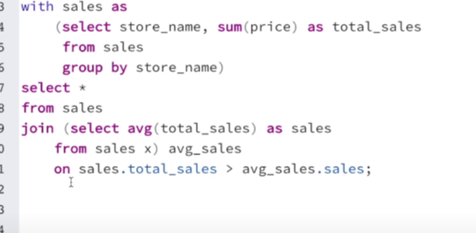

==>clause where we can use sub query

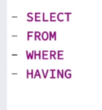

we have already seen the subquery from the from and where



example of subquery with the slelect:

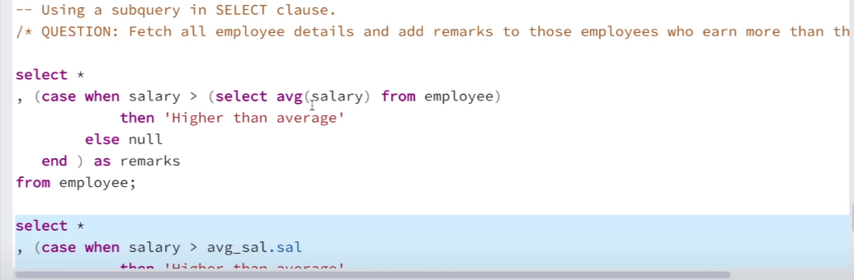

example of sub query with the having calause :

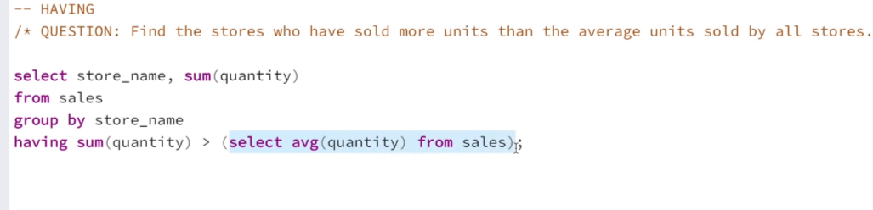

==>Comand where we can use subquery

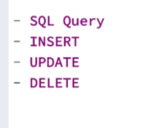

ex with insert :

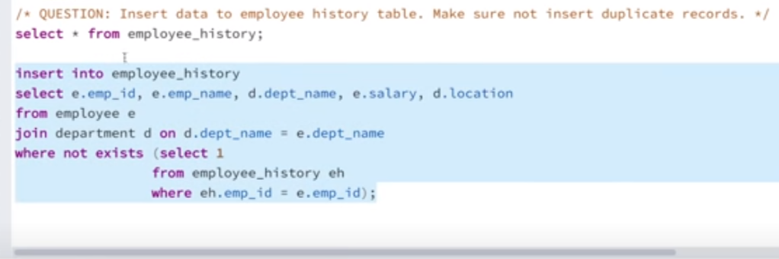

ex with the update :

